# PROJECT REPORT

VISUALIZATION TOOL FOR ELECTRIC VEHICLE CHARGE AND RANGE ANALYSIS

1 INTRODUCTION

* 1. OVERVIEW

A visualization tool for electric vehicle (EV) charge and range analysis is a software application that provides graphical representations and interactive displays of data related to EV charging and range. It allows users to better understand and analyze the charging behaviour, energy consumption, and estimated range of EVs in a visually intuitive way. Charging History Visualization, Range Estimation, Energy Consumption Analysis, Charging Station Visualization, User Customization, Real-time Monitoring, Data Export and Analysis, Overall, a visualization tool for EV charge and range analysis provides an easy-to-understand and interactive way for users to analyze and optimize their EV charging and driving behaviour, helping them make informed decisions and maximize the efficiency and convenience of their EV usage.

1.2 PURPOSE

The purpose of the project "Data Analytics with Tableau as Visualization Tool for Electric Vehicle Charge and Range Analysis" is to utilize data analytics techniques in combination with Tableau, a popular data visualization tool, to analyze and gain insights into electric vehicle (EV) charging patterns and range capabilities.

The project aims to collect and analyze data related to EV charging sessions, such as charging duration, charging power, and location, as well as EV range data, including battery capacity, usage patterns, and driving conditions. By analyzing this data using data analytics techniques, the project seeks to uncover patterns, trends, and correlations that can help understand the charging behaviour of EV users and assess the range capabilities of EVs under different conditions.

Tableau, as a powerful data visualization tool, will be used to create interactive and dynamic visualizations that can help stakeholders, such as EV owners, fleet operators, and policymakers, better understand the data and gain insights. These visualizations may include bar charts, line charts, scatter plots, heat maps, and geographic maps, among others, to effectively convey the analysis results and facilitate decision-making.

The project's overall goal is to leverage data analytics and Tableau visualization to provide meaningful insights and recommendations for improving EV charging infrastructure, optimizing charging strategies, and enhancing EV range management, ultimately contributing to the advancement and adoption of electric mobility.

2 PROBLEM DEFINING & DESIGN THINKING

2.1 EMPATHY MAP

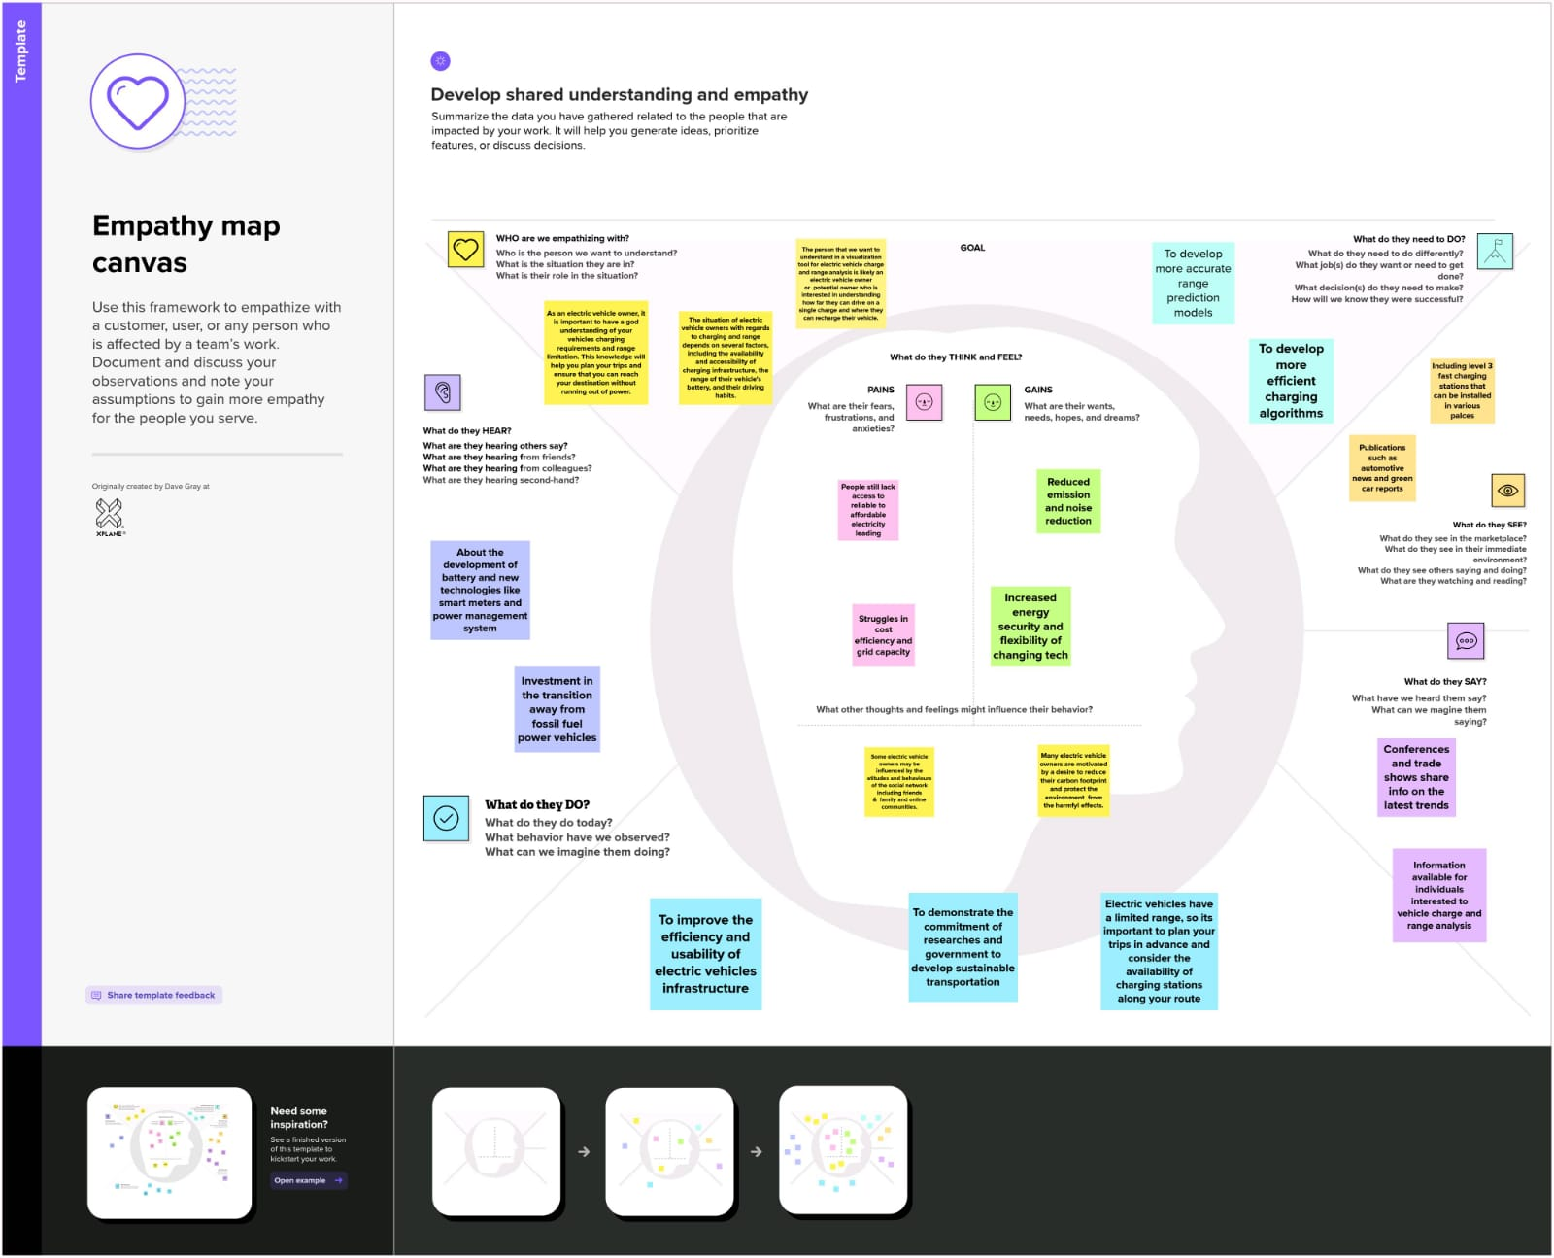

2.2 IDEATION AND BRAINSTORMING MAP

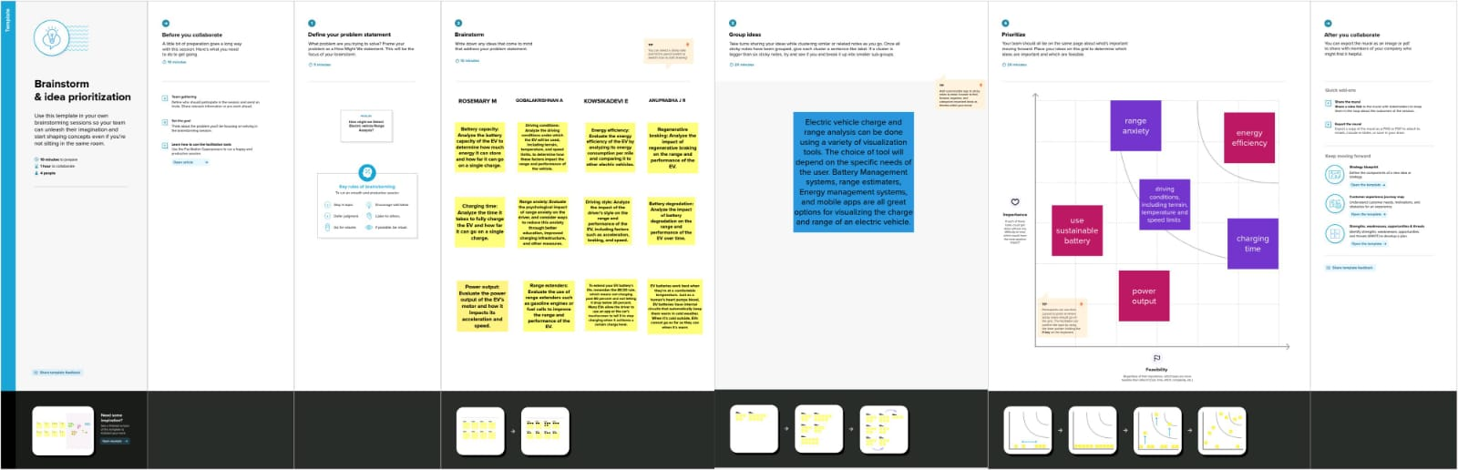

3 RESULT

ACTIVITY & SCREENSHOTS

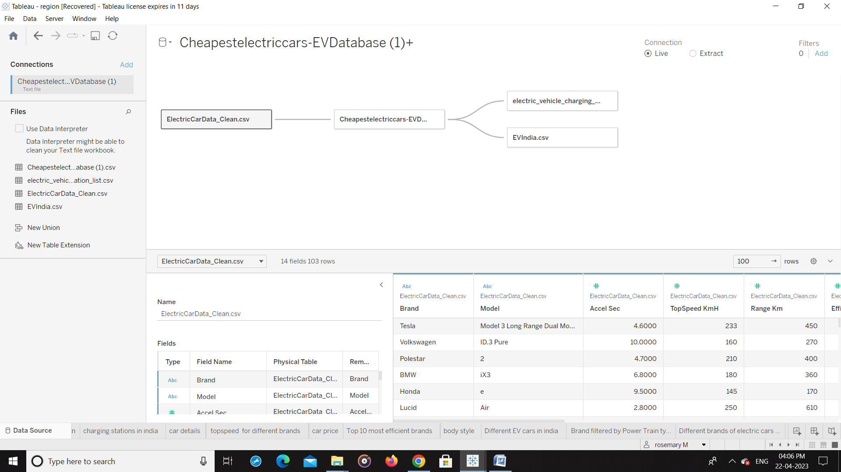

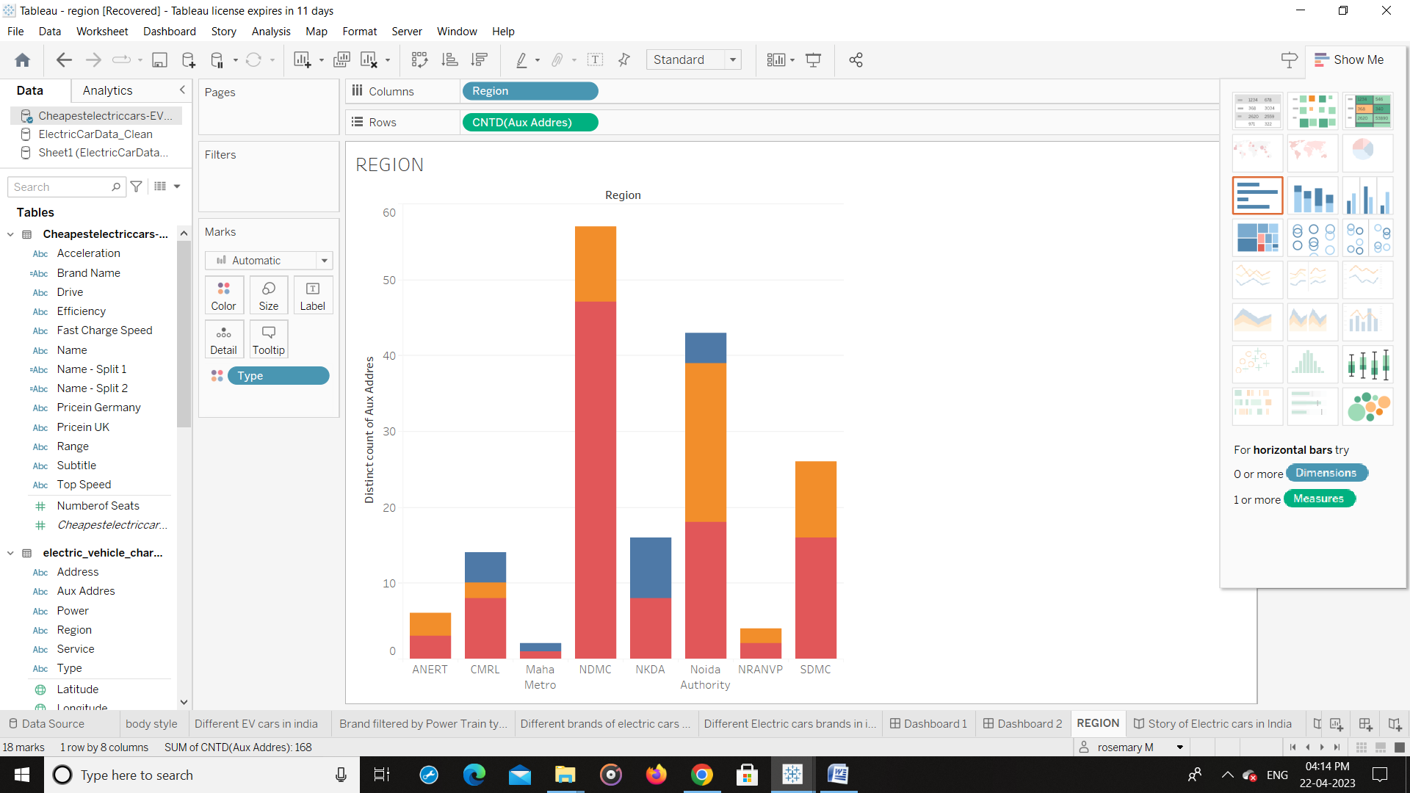

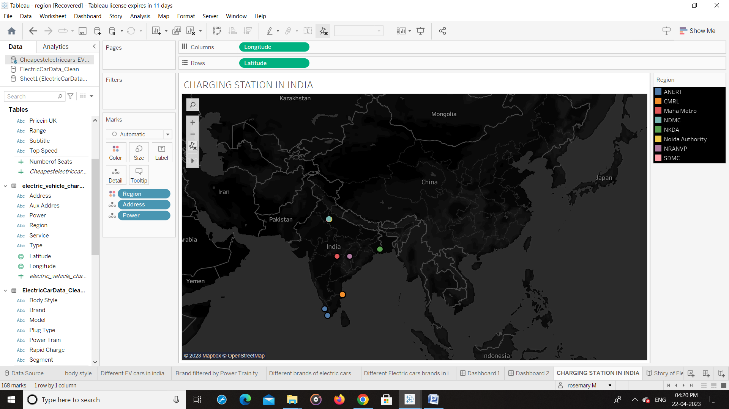

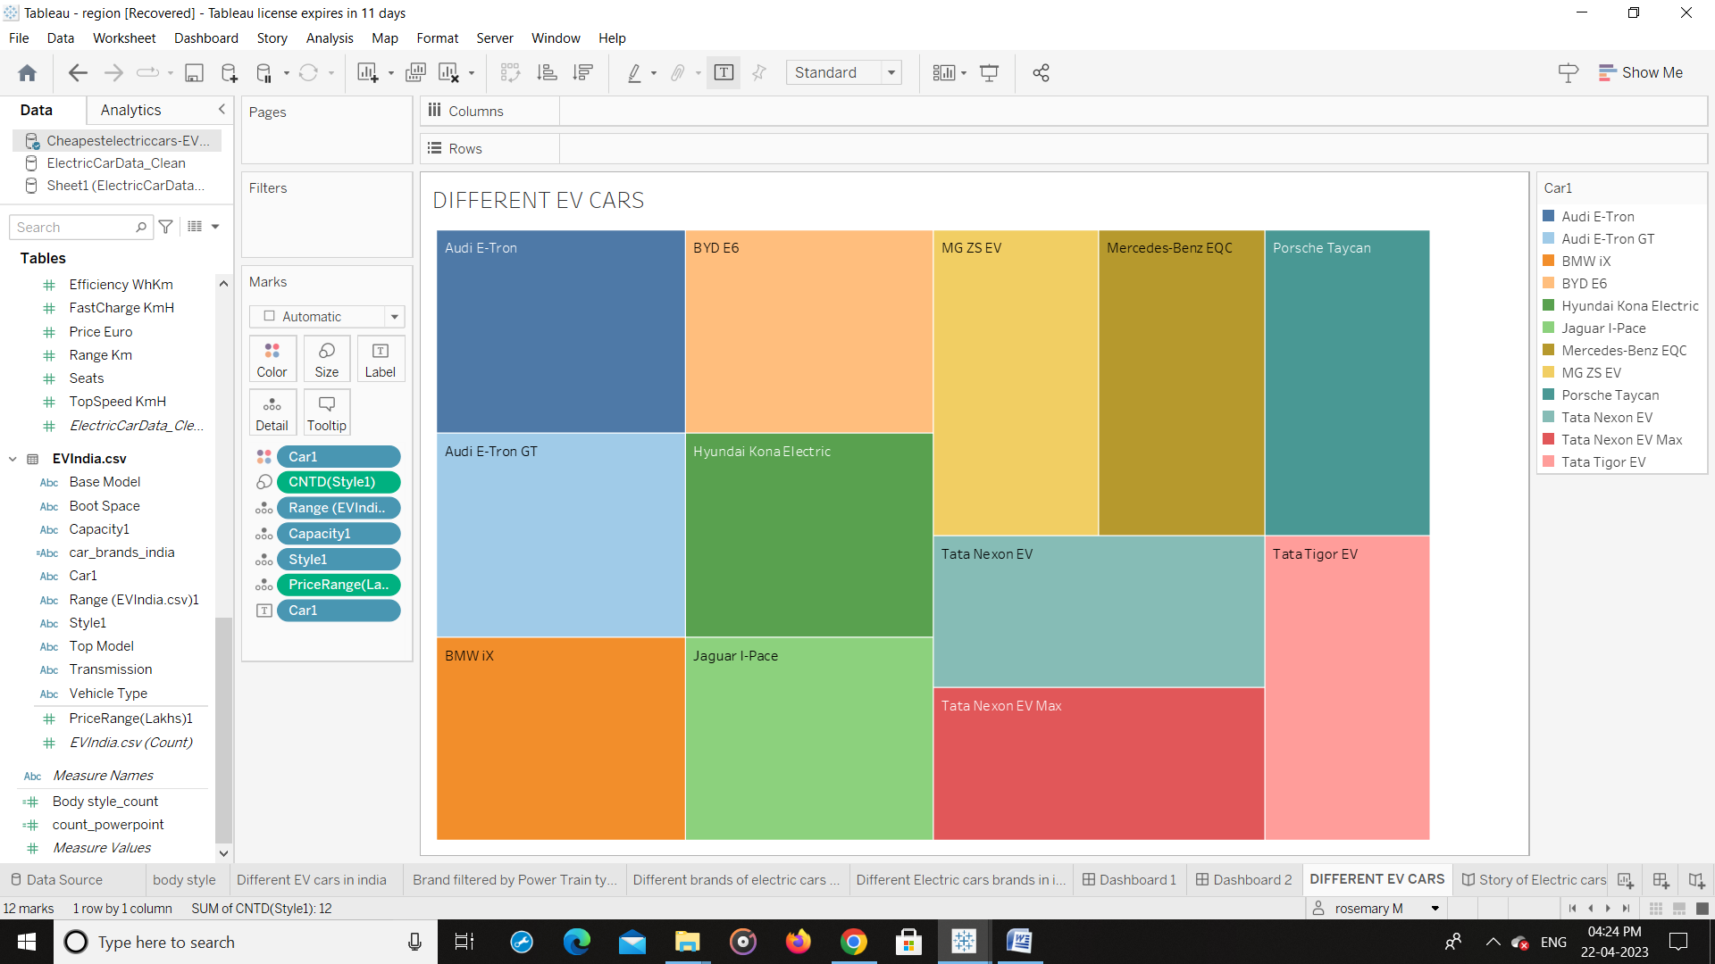

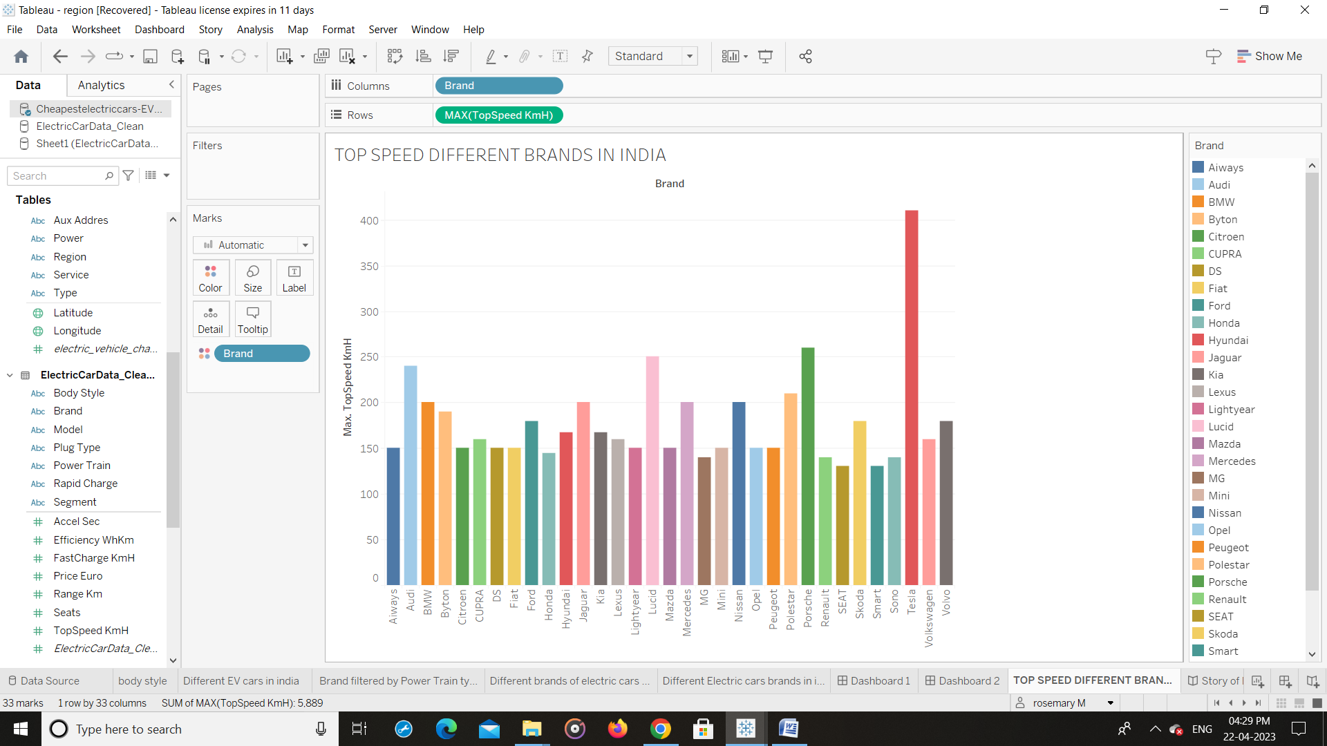

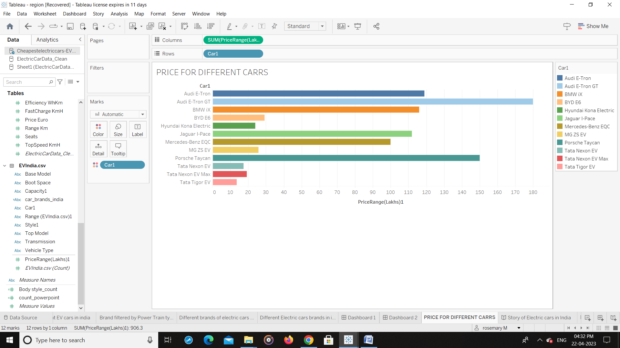

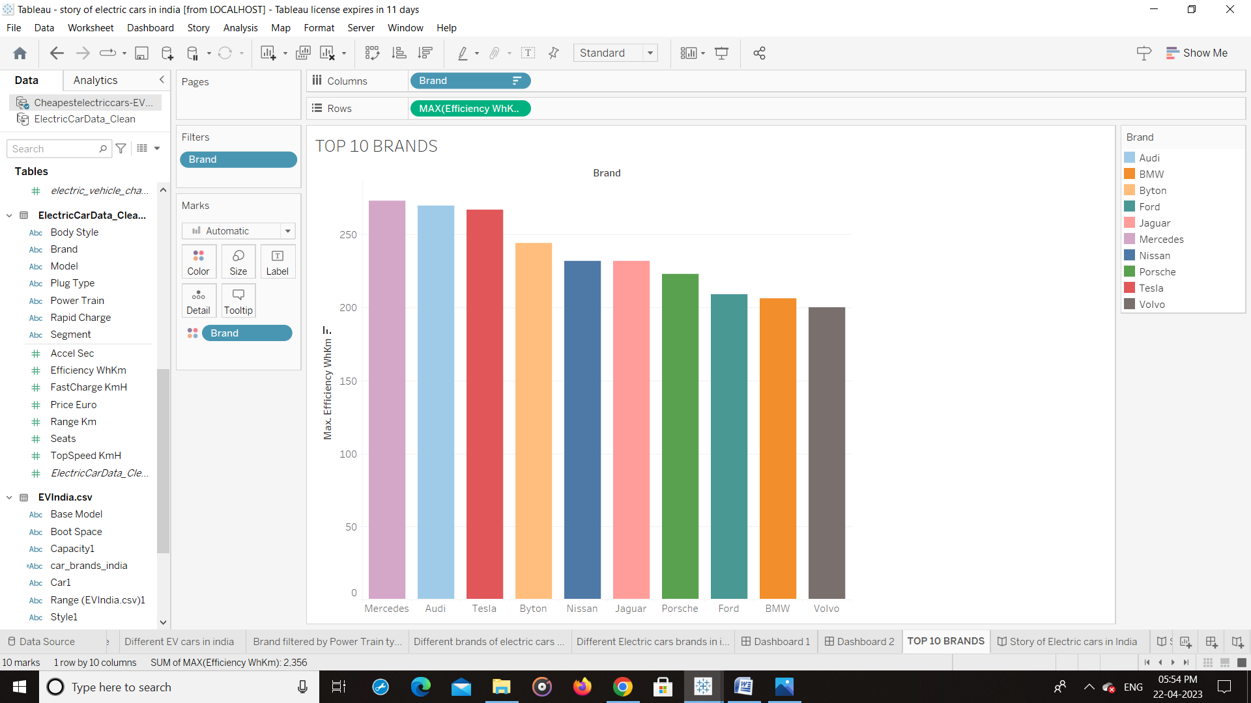

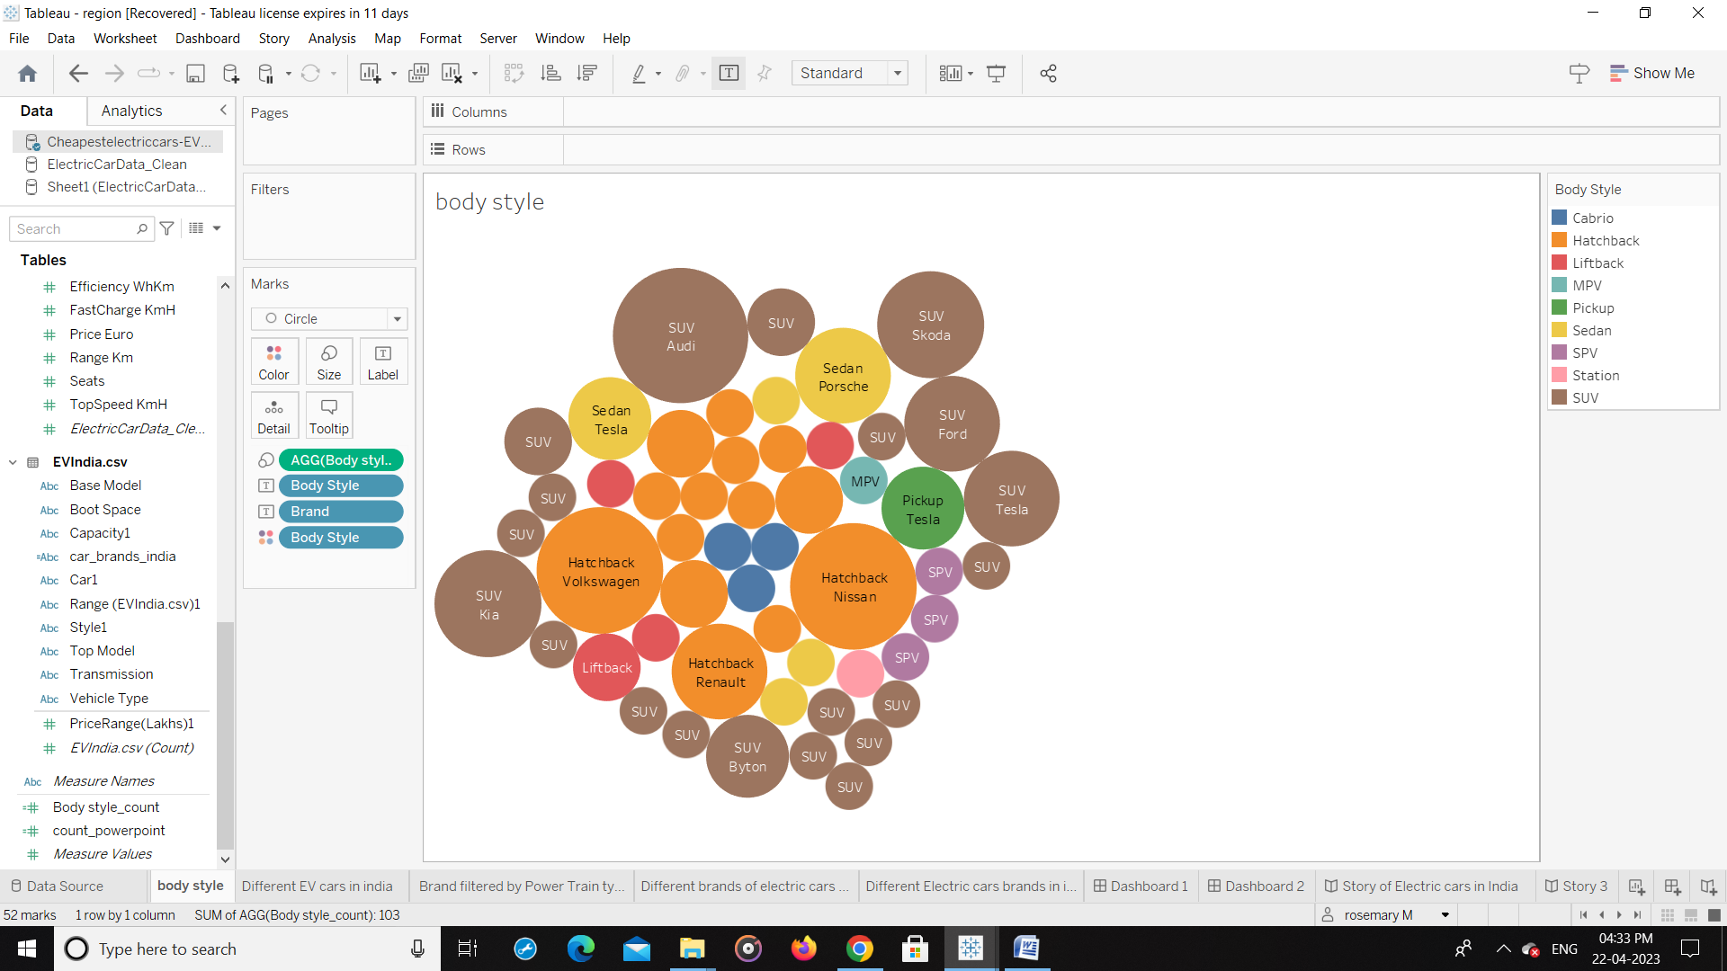

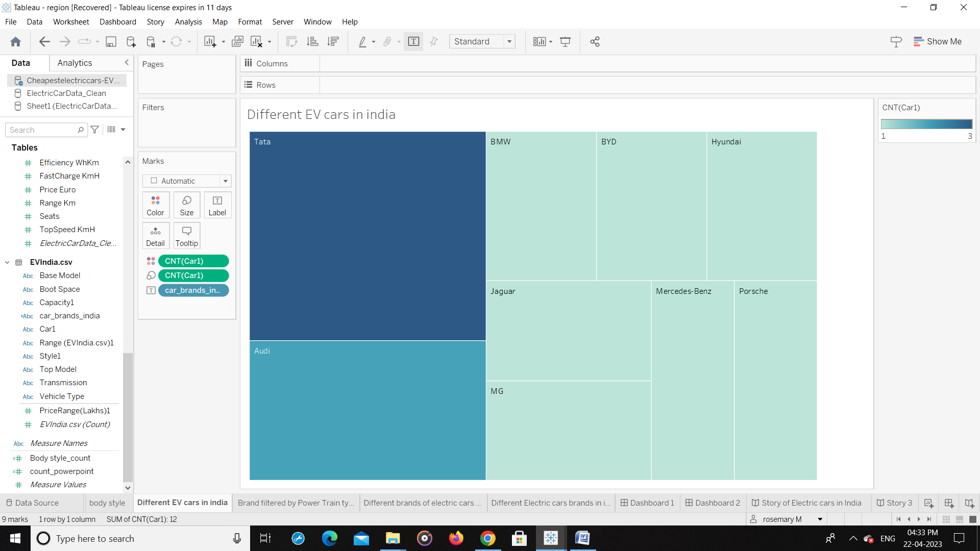

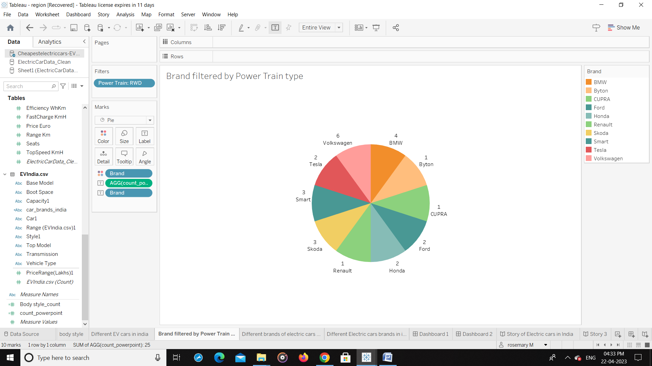

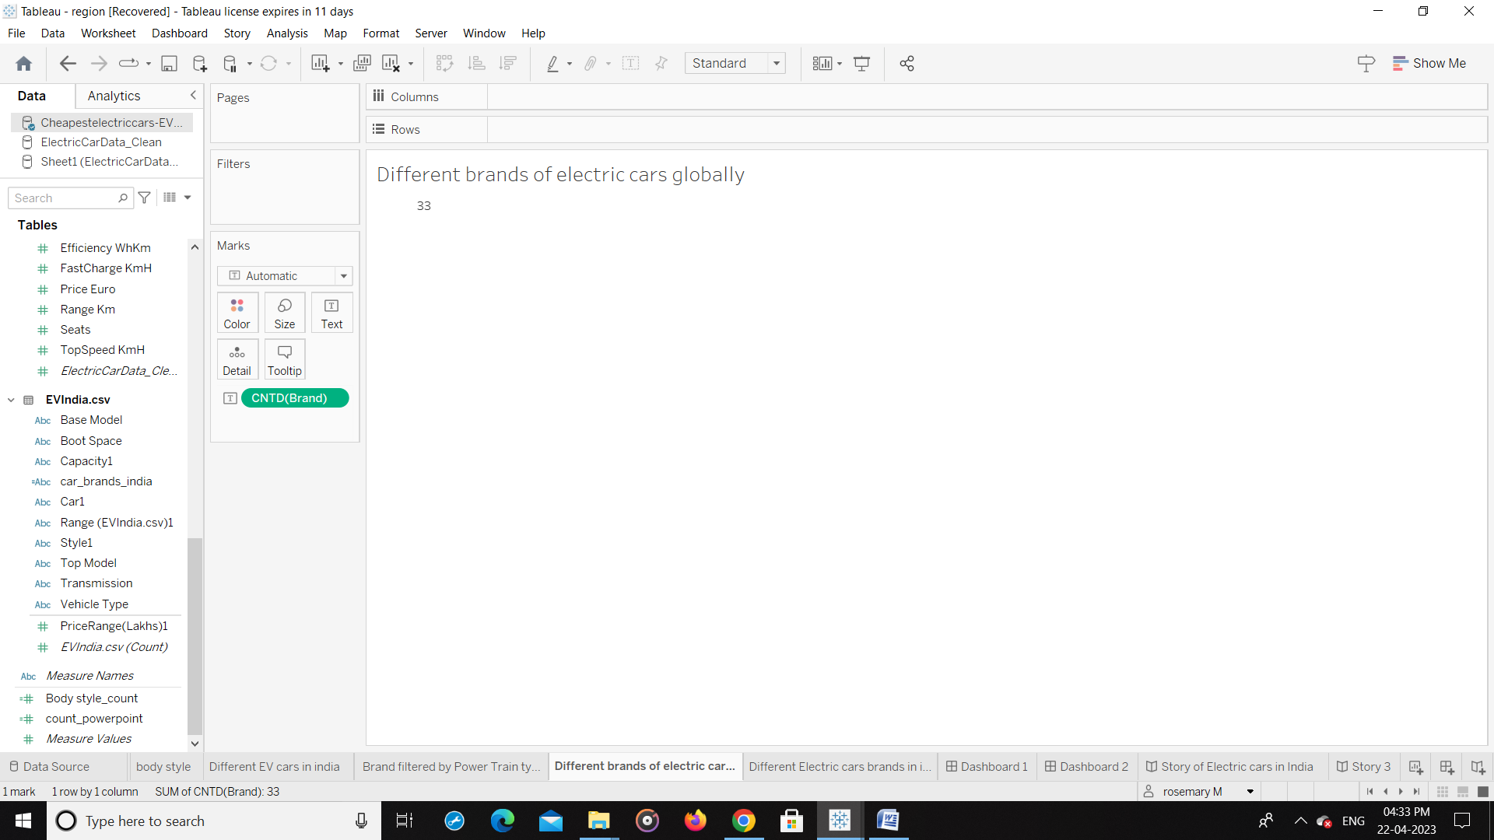

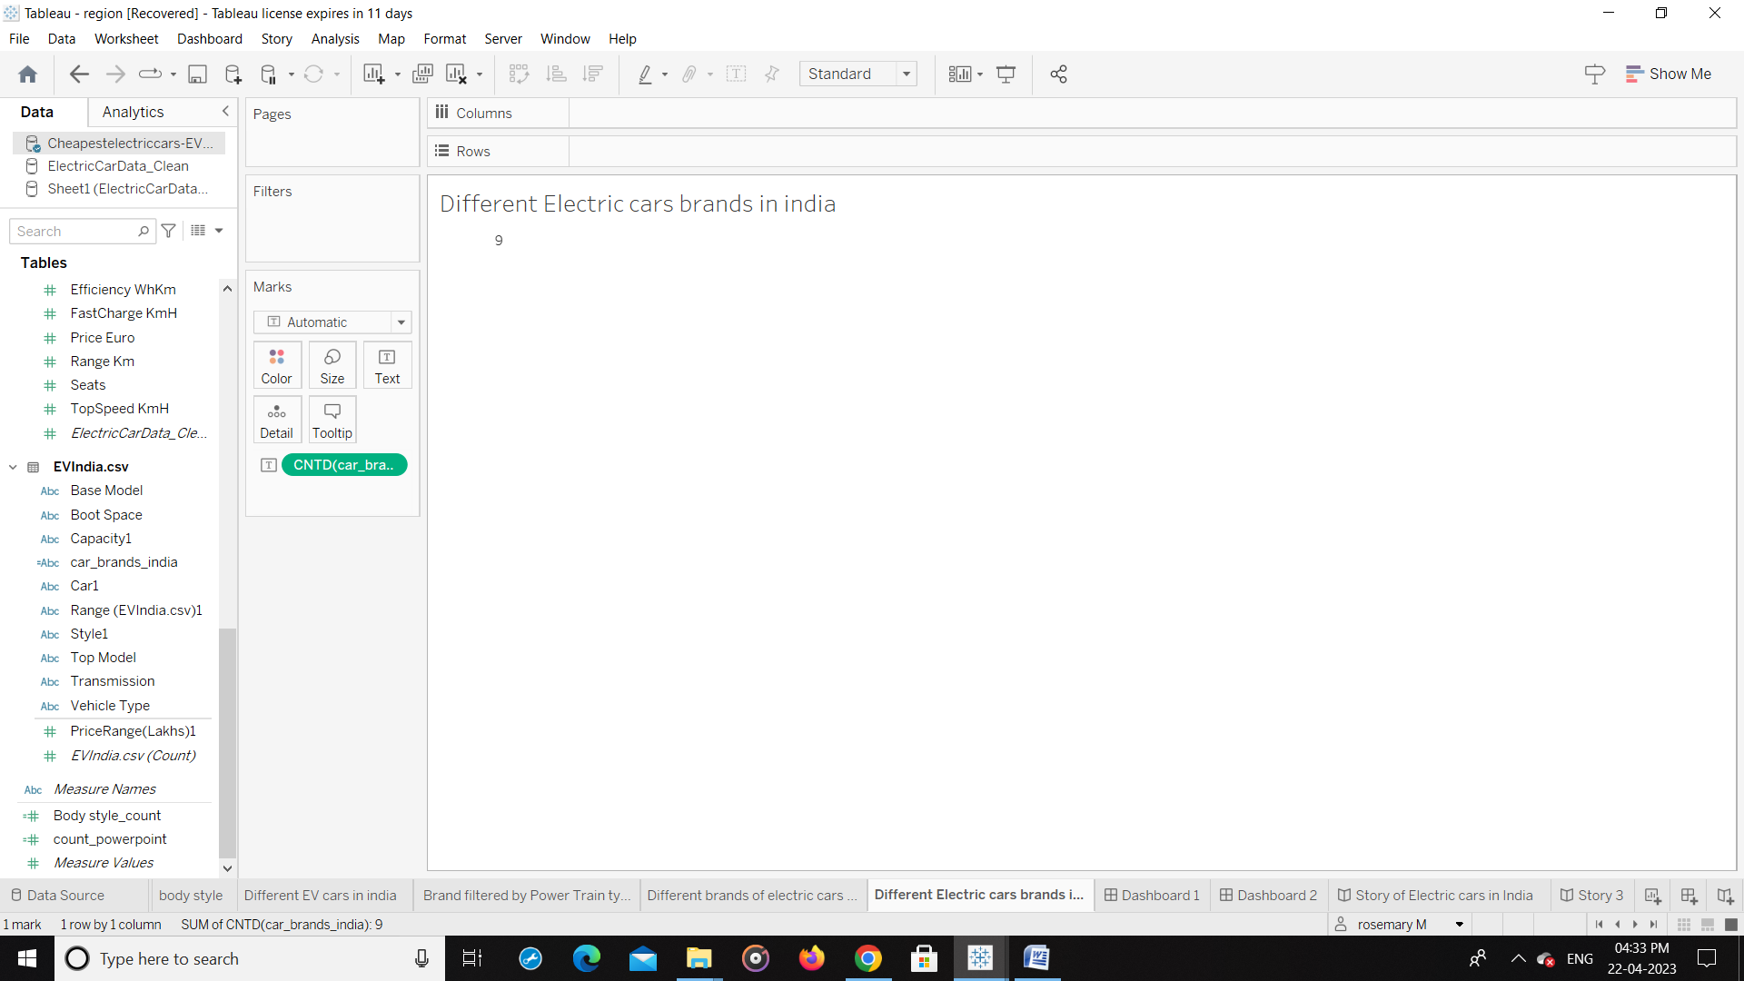

DASHBOARD

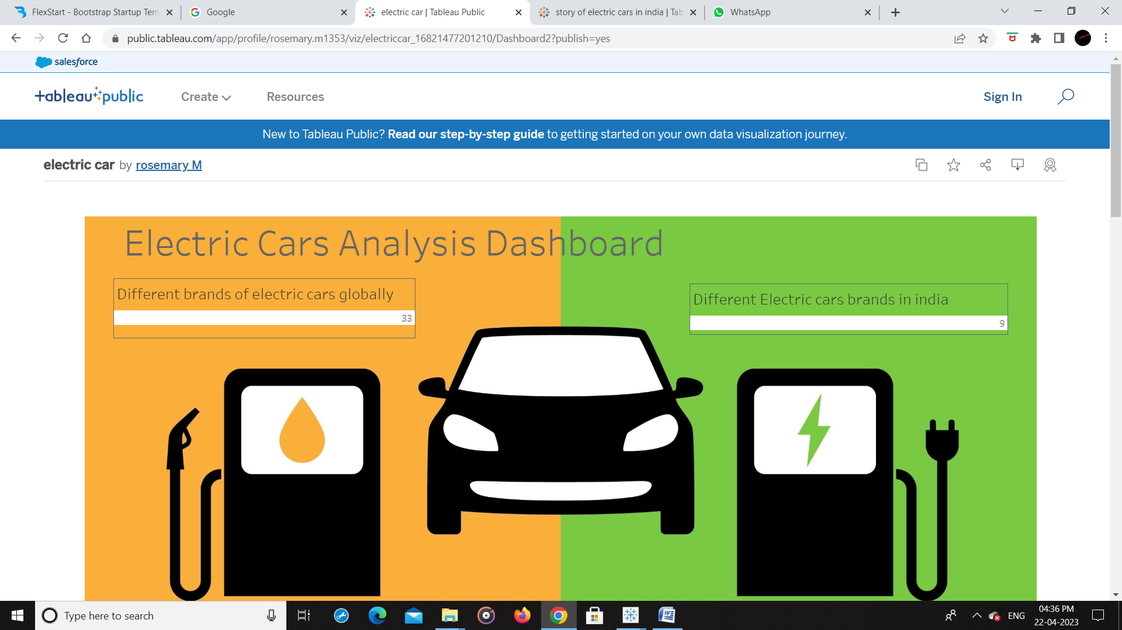

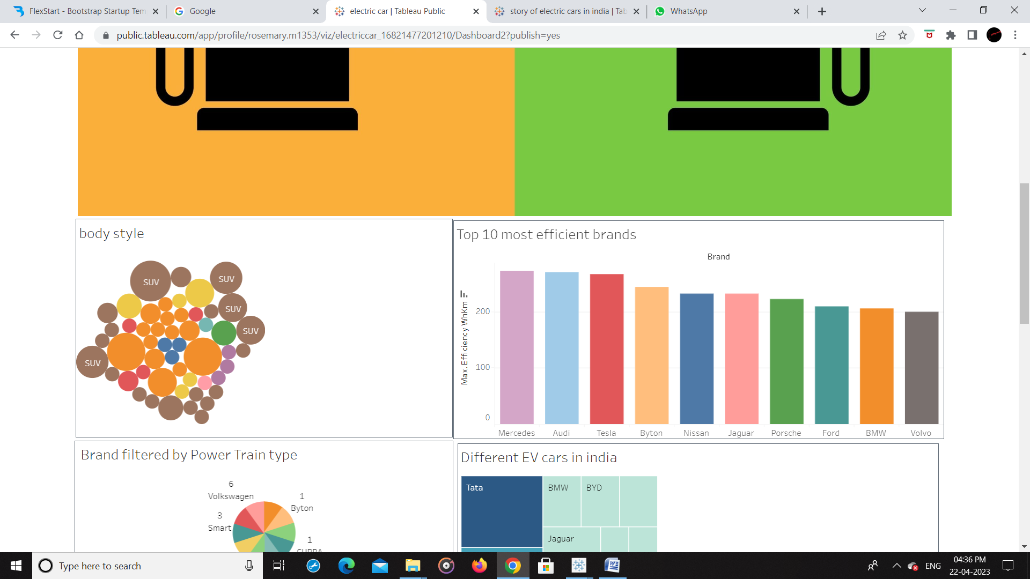

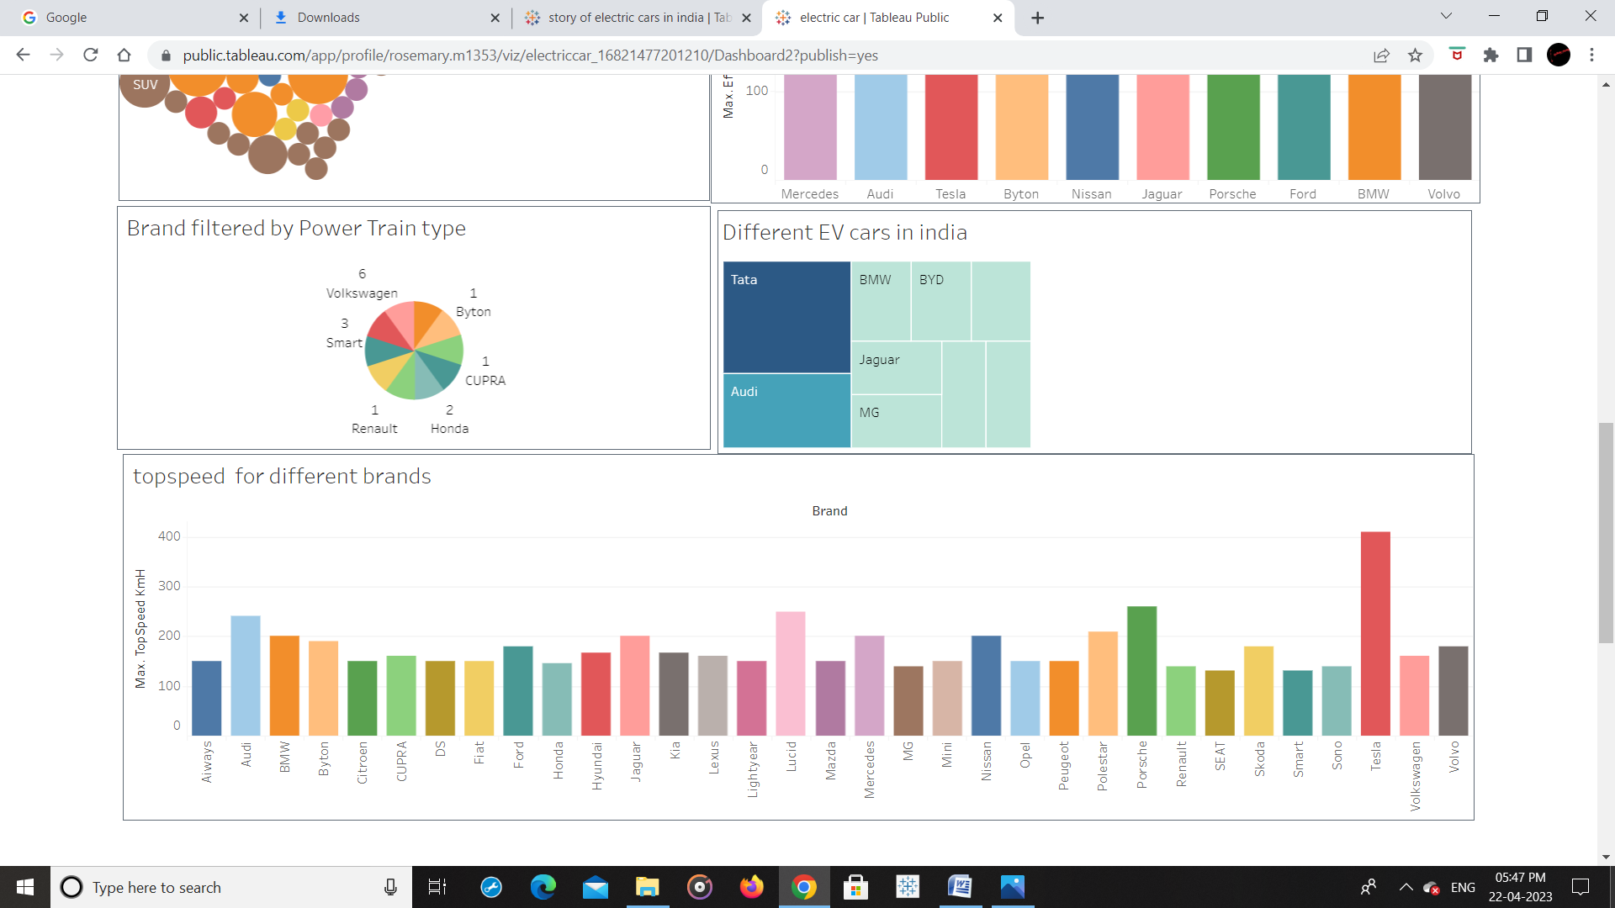

STORY 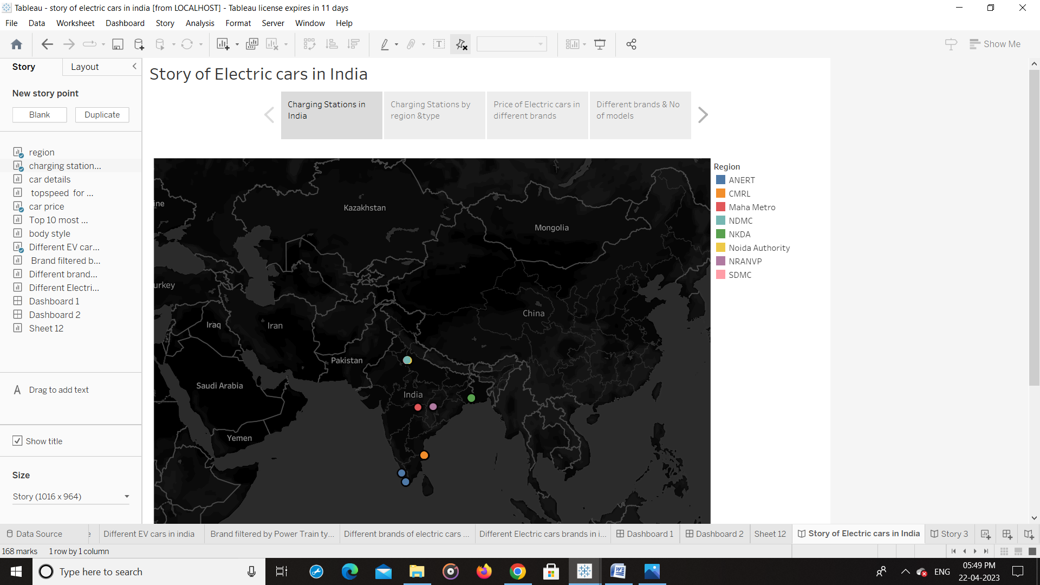

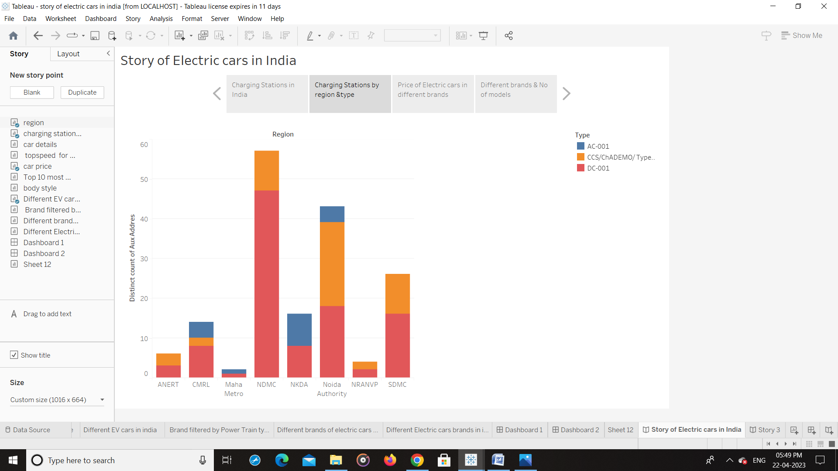

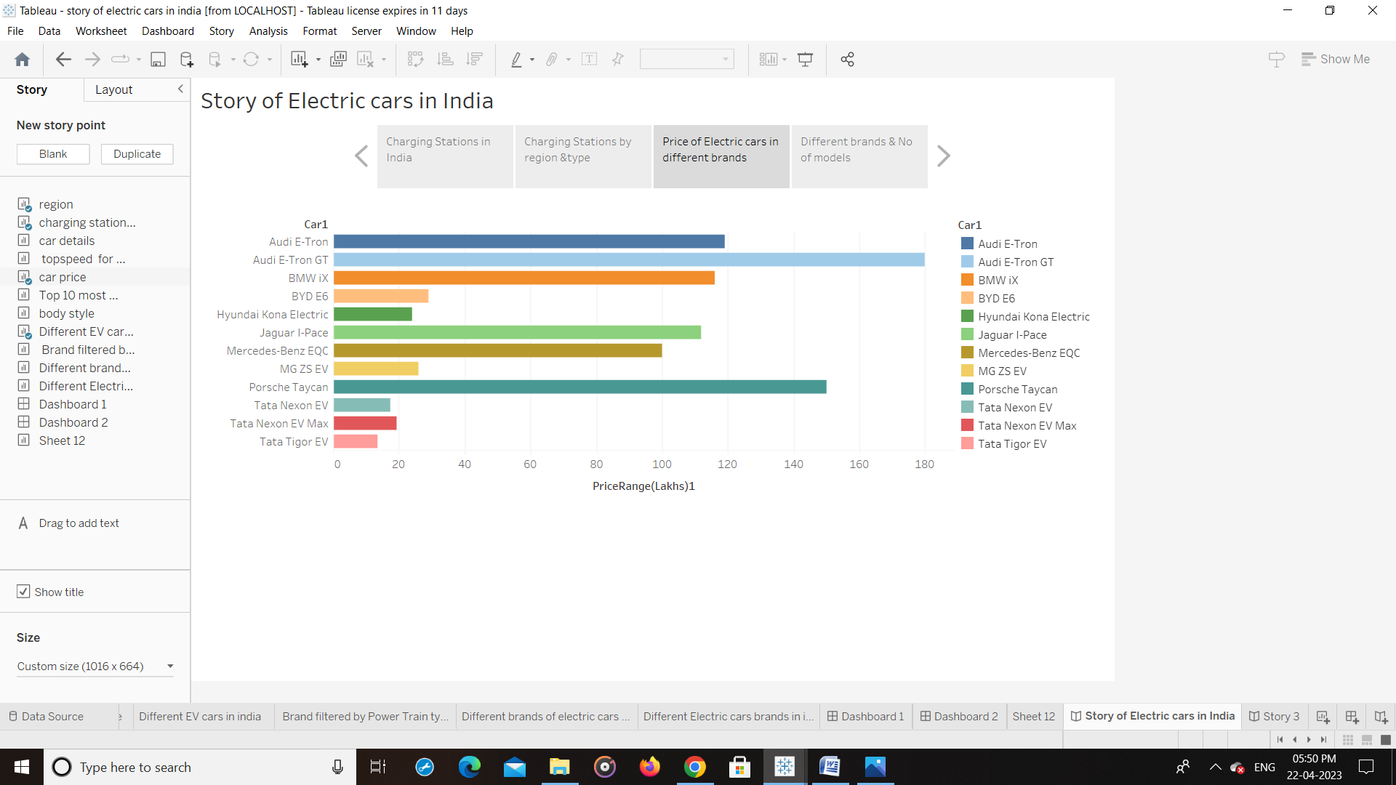

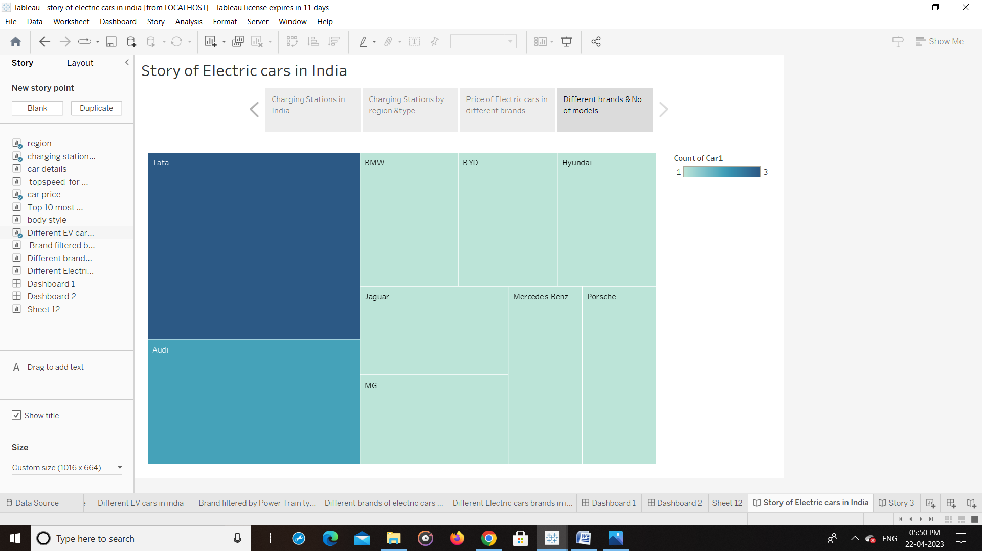

WEB INTEGRATION

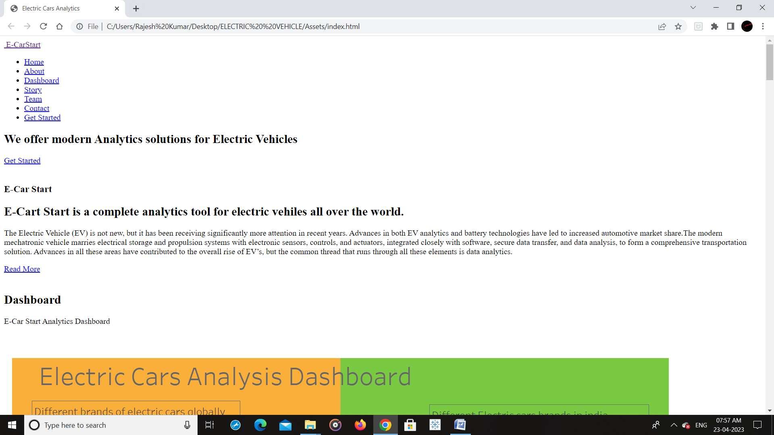

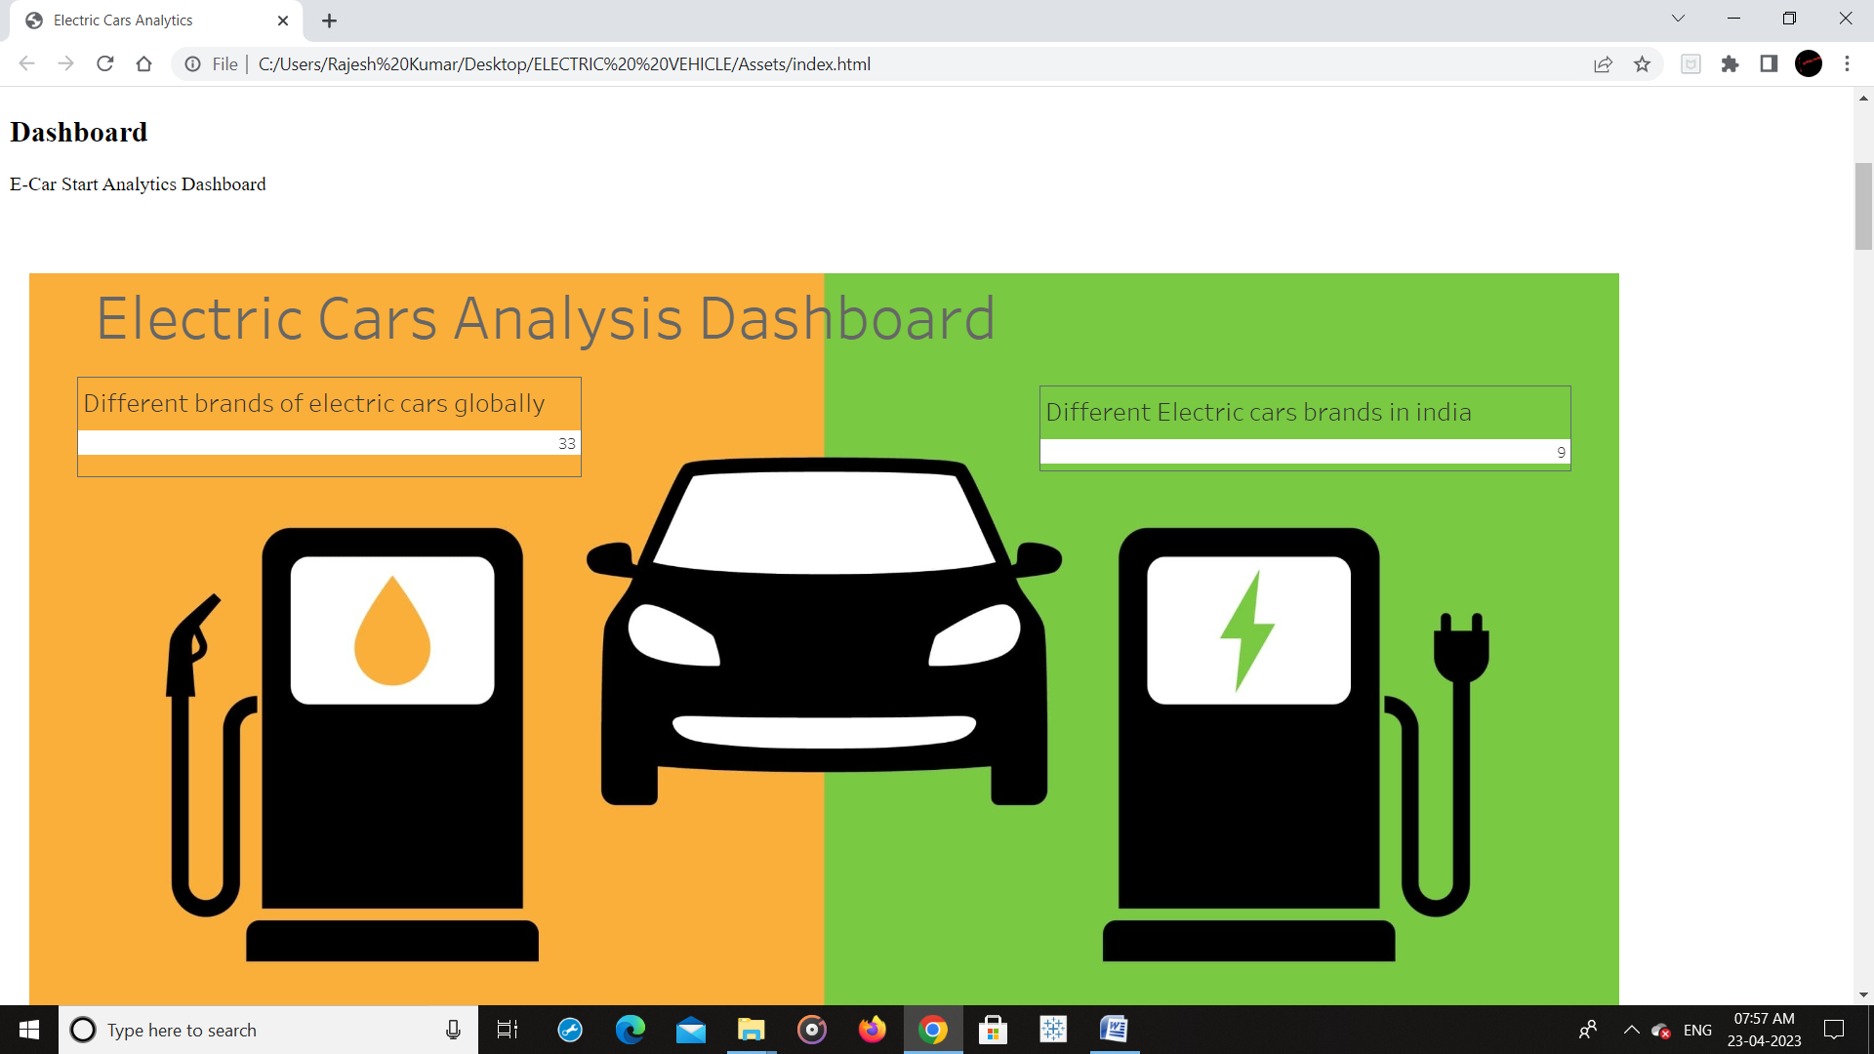

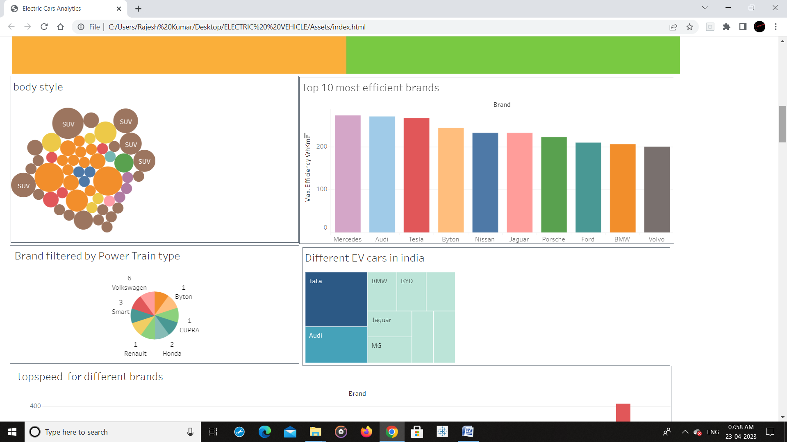

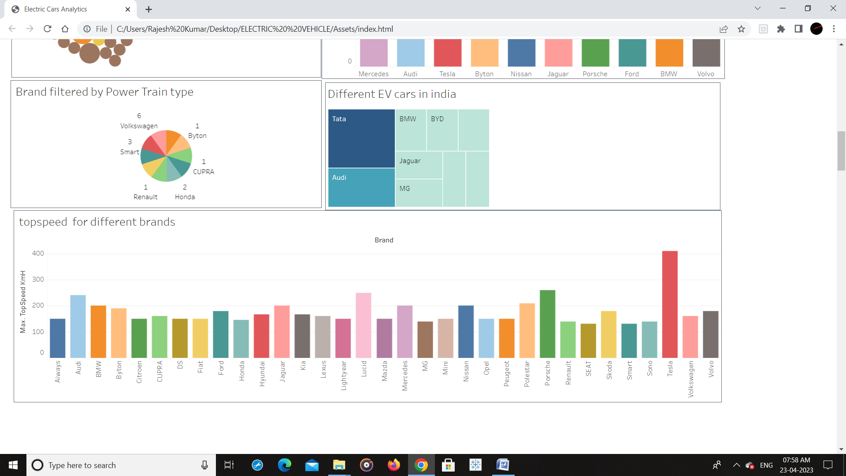

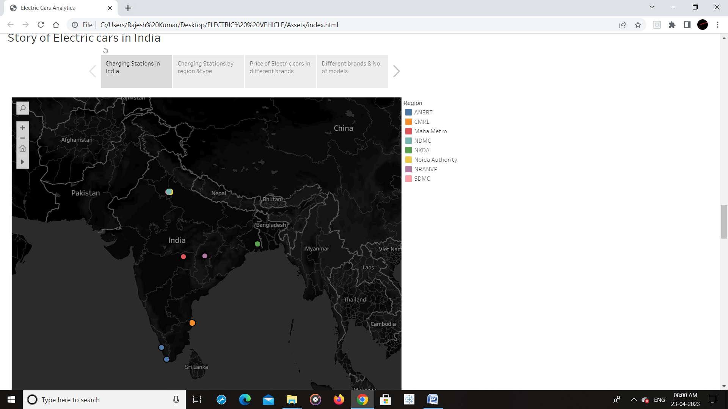

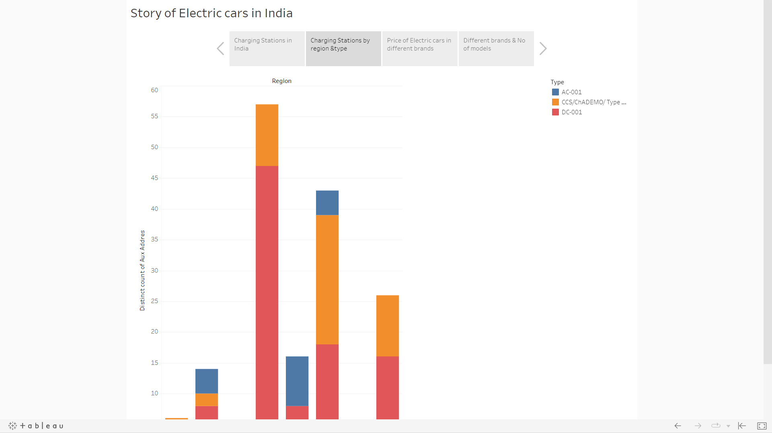

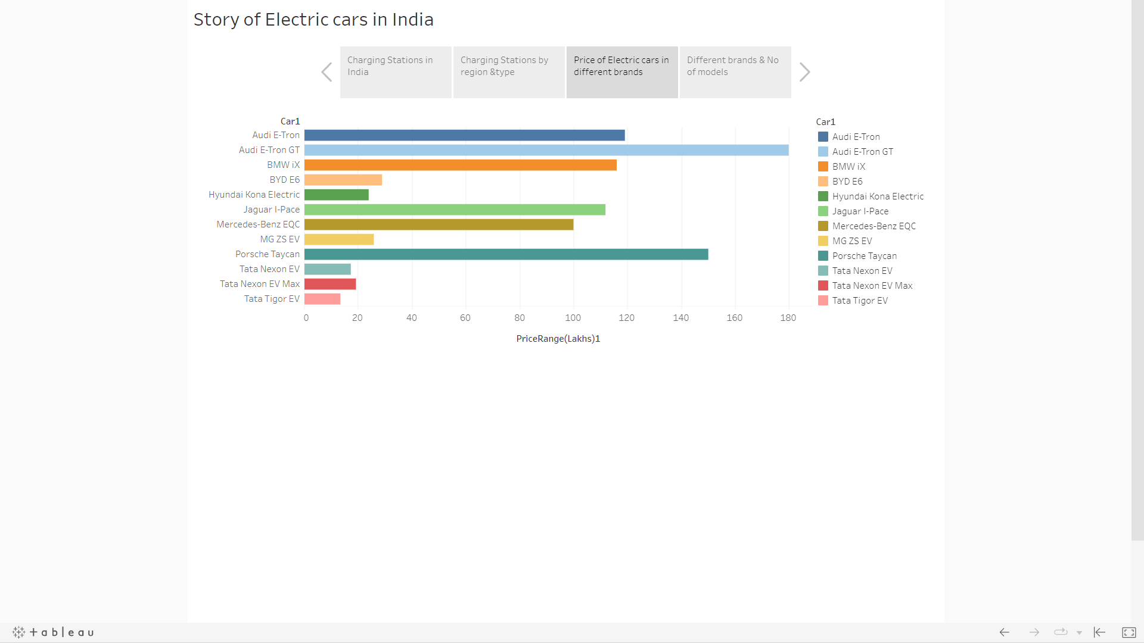

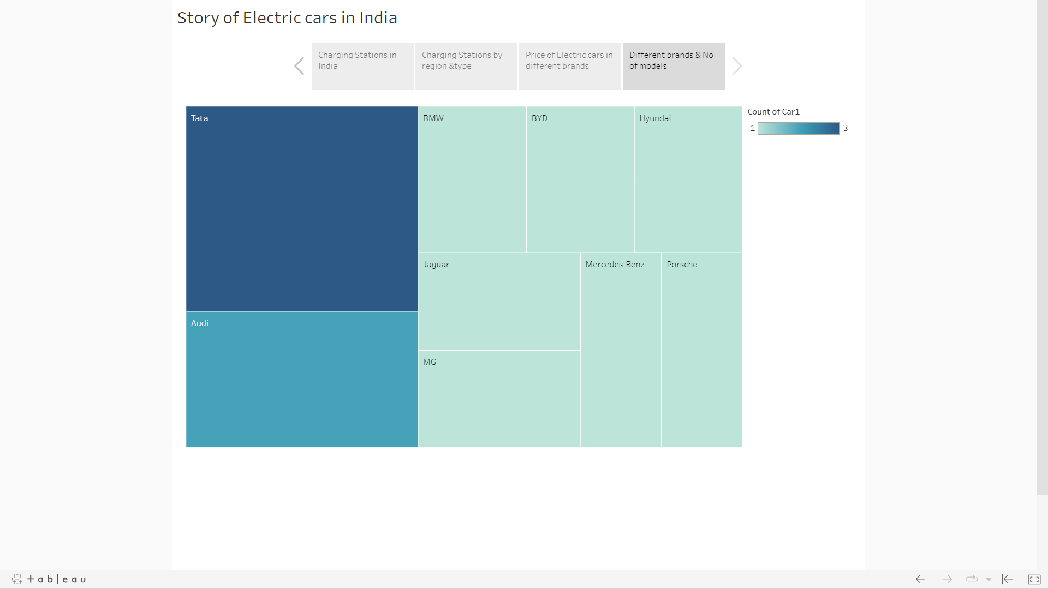

4 TRAILHEAD PROFILE PUBLIC URL

TEAM LEAD - ROSEMARY M – <https://trailblazer.me/id/rsoemrya>

TEAM MEMBER 1 - GOBALAKRISHNAN A - <https://trailblazer.me/id/gobalakrishnan73>

TEAM MEMBER 2 - KOWSIKADEVI E - <https://trailblazer.me/id/kowsikadevi23>

TEAM MEMBER 3 - ANUPRABHA J R - <https://trailblazer.me/id/apnruabha>

5 ADVANTAGES & DISADVANTAGES

Advantages of Visualization Tools for Electric Vehicle Charge and Range Analysis:

* Enhanced Decision Making
* Improved User Experience
* Real-time Monitoring
* Customization and Flexibility

Disadvantages of Visualization Tools for Electric Vehicle Charge and Range Analysis:

* Data Accuracy
* Data Privacy and Security
* Technical Requirements
* Overreliance on Visualizations

6 APPLICATION

Charge Efficiency Analysis: Visualization tools can provide insights into the charging efficiency of an EV, helping users to understand how efficiently their vehicle charges and identify any charging inefficiencies. For example, a visualization tool could display the charging power over time during a charging session, allowing users to see if there are any periods of low charging power that could indicate issues with their charging infrastructure or EV battery.

Range Prediction: Visualization tools can help users estimate the remaining range of their EV based on their current battery state of charge (SOC) and driving behavior. By displaying the predicted range on a map, users can plan their trips more effectively, taking into account the available charging stations along their route and potential range limitations.

Charging Station Mapping: Visualization tools can display the location and availability of charging stations on a map, allowing users to easily locate charging stations near their current location or along a planned route. Users can also filter charging stations based on criteria such as charging speed, charger type, and availability, making it easier to find the most suitable charging station for their needs.

Charging History Analysis: Visualization tools can provide a historical overview of an EV’s charging behavior, allowing users to analyze their charging patterns over time. This can help users identify trends, such as the most frequently used charging stations, average charging duration, and charging costs, which can inform future charging decisions and optimize their EV charging routine.

Cost Analysis: Visualization tools can help users understand the cost of charging their EV, including the cost per kilowatt-hour (kWh) and total charging costs over time. By visualizing the cost data, users can gain insights into the impact of charging behavior on their overall EV charging expenses and make informed decisions about when and where to charge their EV to minimize costs.

Environmental Impact Analysis: Visualization tools can provide information on the environmental impact of charging an EV, such as the amount of greenhouse gas emissions avoided by using renewable energy sources or the reduction in emissions compared to traditional gasoline-powered vehicles. This can help users understand the environmental benefits of driving an EV and make more sustainable choices

7 CONCLUSION

The ultimate goal of the project is to leverage Tableau’s data analytics and visualization capabilities to gain insights into electric vehicle charging and range performance, which can help improve electric vehicle charging infrastructure, optimize vehicle range performance, and promote the adoption of electric vehicles. Visualization tools can play a crucial role in analyzing and optimizing EV charging behavior, providing insights into charging efficiency, range prediction, charging station mapping, charging history, cost analysis, and environmental impact. By visualizing relevant data, users can make informed decisions about how and when to charge their EV, ultimately optimizing their charging routine for maximum efficiency, cost savings, and sustainability.

8 FUTURE SCOPE

The future scope of a visualization tool for electric vehicle (EV) charge and range analysis is significant, as the adoption of EVs is expected to increase rapidly in the coming years. Here are some potential areas of growth and development for such a tool:

* Enhanced User Interface
* Predictive Analytics
* Smart Charging Management
* Range Optimization
* Fleet Management
* Integration with Smart Home and Renewable Energy Systems
* Augmented Reality (AR) and Virtual Reality (VR) Visualization

In conclusion, the future scope of a visualization tool for EV charge and range analysis is vast, with opportunities for advanced analytics, smart charging management, range optimization, fleet management, gamification, integration with smart home and renewable energy systems, and AR/VR visualization. Such a tool can empower EV owners with valuable insights and recommendations to optimize their charging and driving experience, contributing to the widespread adoption of EVs and the transition to a sustainable transportation future.

9 APPENDIX

Source code

<!DOCTYPE html>

<html lang="en">

<head>

  <meta charset="utf-8">

  <meta content="width=device-width, initial-scale=1.0" name="viewport">

  <title>Electric Cars Analytics</title>

  <meta content="" name="description">

  <meta content="" name="keywords">

  <!-- Favicons -->

  <link href="assets/img/favicon.png" rel="icon">

  <link href="assets/img/apple-touch-icon.png" rel="apple-touch-icon">

  <!-- Google Fonts -->

  <link href="https://fonts.googleapis.com/css?family=Open+Sans:300,300i,400,400i,600,600i,700,700i|Nunito:300,300i,400,400i,600,600i,700,700i|Poppins:300,300i,400,400i,500,500i,600,600i,700,700i" rel="stylesheet">

  <!-- Vendor CSS Files -->

  <link href="assets/vendor/aos/aos.css" rel="stylesheet">

  <link href="assets/vendor/bootstrap/css/bootstrap.min.css" rel="stylesheet">

  <link href="assets/vendor/bootstrap-icons/bootstrap-icons.css" rel="stylesheet">

  <link href="assets/vendor/glightbox/css/glightbox.min.css" rel="stylesheet">

  <link href="assets/vendor/remixicon/remixicon.css" rel="stylesheet">

  <link href="assets/vendor/swiper/swiper-bundle.min.css" rel="stylesheet">

  <!-- Template Main CSS File -->

  <link href="assets/css/style.css" rel="stylesheet">

  <!-- =======================================================

  * Template Name: FlexStart - v1.12.0

  * Template URL: https://bootstrapmade.com/flexstart-bootstrap-startup-template/

  * Author: BootstrapMade.com

  * License: https://bootstrapmade.com/license/

  ======================================================== -->

</head>

<body>

  <!-- ======= Header ======= -->

  <header id="header" class="header fixed-top">

    <div class="container-fluid container-xl d-flex align-items-center justify-content-between">

      <a href="index.html" class="logo d-flex align-items-center">

        <img src="assets/img/logo.png" alt="">

        <span>E-CarStart</span>

      </a>

      <nav id="navbar" class="navbar">

        <ul>

          <li><a class="nav-link scrollto active" href="#hero">Home</a></li>

          <li><a class="nav-link scrollto" href="#about">About</a></li>

          <li><a class="nav-link scrollto" href="#values">Dashboard</a></li>

          <li><a class="nav-link scrollto" href="#services">Story</a></li>

          <li><a class="nav-link scrollto" href="#team">Team</a></li>

          <li><a class="nav-link scrollto" href="#contact">Contact</a></li>

          <li><a class="getstarted scrollto" href="#about">Get Started</a></li>

        </ul>

        <i class="bi bi-list mobile-nav-toggle"></i>

      </nav><!-- .navbar -->

    </div>

  </header><!-- End Header -->

  <!-- ======= Hero Section ======= -->

  <section id="hero" class="hero d-flex align-items-center">

    <div class="container">

      <div class="row">

        <div class="col-lg-6 d-flex flex-column justify-content-center">

          <h1 data-aos="fade-up">We offer modern Analytics solutions for Electric Vehicles</h1>

          <div data-aos="fade-up" data-aos-delay="600">

            <div class="text-center text-lg-start">

              <a href="#about" class="btn-get-started scrollto d-inline-flex align-items-center justify-content-center align-self-center">

                <span>Get Started</span>

                <i class="bi bi-arrow-right"></i>

              </a>

            </div>

          </div>

        </div>

        <div class="col-lg-6 hero-img" data-aos="zoom-out" data-aos-delay="200">

          <img src="assets\img\12085817_20944306.jpg" class="img-fluid" alt="">

        </div>

      </div>

    </div>

  </section><!-- End Hero -->

  <main id="main">

    <!-- ======= About Section ======= -->

    <section id="about" class="about">

      <div class="container" data-aos="fade-up">

        <div class="row gx-0">

          <div class="col-lg-6 d-flex flex-column justify-content-center" data-aos="fade-up" data-aos-delay="200">

            <div class="content">

              <h3>E-Car Start</h3>

              <h2>E-Cart Start is a complete analytics tool for electric vehiles all over the world.</h2>

              <p>

                The Electric Vehicle (EV) is not new, but it has been receiving significantly more attention in recent years. Advances in both EV analytics and battery technologies have led to increased automotive market share.The modern mechatronic vehicle marries electrical storage and propulsion systems with electronic sensors, controls, and actuators, integrated closely with software, secure data transfer, and data analysis, to form a comprehensive transportation solution. Advances in all these areas have contributed to the overall rise of EV’s, but the common thread that runs through all these elements is data analytics.

              </p>

              <div class="text-center text-lg-start">

                <a href="#" class="btn-read-more d-inline-flex align-items-center justify-content-center align-self-center">

                  <span>Read More</span>

                  <i class="bi bi-arrow-right"></i>

                </a>

              </div>

            </div>

          </div>

          <div class="col-lg-6 d-flex align-items-center" data-aos="zoom-out" data-aos-delay="200">

            <img src="assets\img\EV.jpeg" class="img-fluid" alt="">

          </div>

        </div>

      </div>

    </section><!-- End About Section -->

    <!-- ======= Values Section ======= -->

    <section id="values" class="values">

      <div class="container" data-aos="fade-up">

        <header class="section-header">

          <h2>Dashboard</h2>

          <p>E-Car Start Analytics Dashboard</p>

        </header>

        <div class="row">

          <div <div class='tableauPlaceholder' id='viz1682156786516' style='position: relative'><noscript><a href='#'><img alt='Dashboard 2 ' src='https:&#47;&#47;public.tableau.com&#47;static&#47;images&#47;el&#47;electriccar_16821477201210&#47;Dashboard2&#47;1_rss.png' style='border: none' /></a></noscript><object class='tableauViz'  style='display:none;'><param name='host_url' value='https%3A%2F%2Fpublic.tableau.com%2F' /> <param name='embed_code_version' value='3' /> <param name='site_root' value='' /><param name='name' value='electriccar_16821477201210&#47;Dashboard2' /><param name='tabs' value='no' /><param name='toolbar' value='yes' /><param name='static_image' value='https:&#47;&#47;public.tableau.com&#47;static&#47;images&#47;el&#47;electriccar_16821477201210&#47;Dashboard2&#47;1.png' /> <param name='animate_transition' value='yes' /><param name='display_static_image' value='yes' /><param name='display_spinner' value='yes' /><param name='display_overlay' value='yes' /><param name='display_count' value='yes' /><param name='language' value='en-US' /><param name='filter' value='publish=yes' /></object></div>                <script type='text/javascript'>                    var divElement = document.getElementById('viz1682156786516');                    var vizElement = divElement.getElementsByTagName('object')[0];                    if ( divElement.offsetWidth > 800 ) { vizElement.style.width='1320px';vizElement.style.height='2027px';} else if ( divElement.offsetWidth > 500 ) { vizElement.style.width='1320px';vizElement.style.height='2027px';} else { vizElement.style.width='100%';vizElement.style.height='2177px';}                     var scriptElement = document.createElement('script');                    scriptElement.src = 'https://public.tableau.com/javascripts/api/viz_v1.js';                    vizElement.parentNode.insertBefore(scriptElement, vizElement);                </script>

        </div>

      </div>

    </section><!-- End Values Section -->

    <!-- ======= Features Section ======= -->

    <section id="features" class="features">

      <div class="container" data-aos="fade-up">

        <header class="section-header">

          <h2>Features</h2>

          <p>There are many different features of our project</p>

        </header>

        <div class="row">

          <div class="col-lg-6">

            <img src="assets/img/features.png" class="img-fluid" alt="">

          </div>

          <div class="col-lg-6 mt-5 mt-lg-0 d-flex">

            <div class="row align-self-center gy-4">

              <div class="col-md-6" data-aos="zoom-out" data-aos-delay="200">

                <div class="feature-box d-flex align-items-center">

                  <i class="bi bi-check"></i>

                  <h3>Analyse the currect stats</h3>

                </div>

              </div>

              <div class="col-md-6" data-aos="zoom-out" data-aos-delay="300">

                <div class="feature-box d-flex align-items-center">

                  <i class="bi bi-check"></i>

                  <h3>Get to know EV more</h3>

                </div>

              </div>

              <div class="col-md-6" data-aos="zoom-out" data-aos-delay="400">

                <div class="feature-box d-flex align-items-center">

                  <i class="bi bi-check"></i>

                  <h3>Know about Charging Stations</h3>

                </div>

              </div>

              <div class="col-md-6" data-aos="zoom-out" data-aos-delay="500">

                <div class="feature-box d-flex align-items-center">

                  <i class="bi bi-check"></i>

                  <h3>Top performing Brands</h3>

                </div>

              </div>

              <div class="col-md-6" data-aos="zoom-out" data-aos-delay="600">

                <div class="feature-box d-flex align-items-center">

                  <i class="bi bi-check"></i>

                  <h3>different brands in India</h3>

                </div>

              </div>

              <div class="col-md-6" data-aos="zoom-out" data-aos-delay="700">

                <div class="feature-box d-flex align-items-center">

                  <i class="bi bi-check"></i>

                  <h3>different brands Globally</h3>

                </div>

              </div>

            </div>

          </div>

        </div> <!-- / row -->

        <!-- Feature Tabs -->

        <div class="row feture-tabs" data-aos="fade-up">

          <div class="col-lg-6">

            <h3>Overview of Electric Vehicle Sector</h3>

            <!-- Tabs -->

            <ul class="nav nav-pills mb-3">

              <li>

                <a class="nav-link active" data-bs-toggle="pill" href="#tab1">Overview</a>

              </li>

              <li>

                <a class="nav-link active" data-bs-toggle="pill" href="#tab2">Pricing</a>

              </li>

            </ul><!-- End Tabs -->

            <!-- Tab Content -->

            <div class="tab-content">

              <div class="tab-pane fade show active" id="tab1">

                <p>The supply of fossil fuels is constantly decreasing. The situation is very alarming. It is time for the world to slowly adapt to electric vehicles. </p>

                <div class="d-flex align-items-center mb-2">

                  <i class="bi bi-check2"></i>

                  <h4>A lot of change needs to happen</h4>

                </div>

                <p>Major carmakers like Tesla and Porsche manufacture many electric vehicles. </p>

                <div class="d-flex align-items-center mb-2">

                  <i class="bi bi-check2"></i>

                  <h4> The improvement of battery technology in recent years has led to the higher popularity of electric vehicles.</h4>

                </div>

                <p>Buying an electric vehicle can be a great choice for consumers. The drive quality, low noise levels, and convenience are really great.</p>

              </div><!-- End Tab 1 Content -->

              <div class="tab-pane fade show" id="tab2">

                <p> In the United States, one year of driving a petrol car can cost from 1500 USD to 2500 USD.</p>

                <div class="d-flex align-items-center mb-2">

                  <i class="bi bi-check2"></i>

                  <h4>On the other hand, the driving cost of Electric Vehicles is 500 USD. Electric cars are more preferable.</h4>

                </div>

                <p>The maintenance cost of electric vehicles is also very low. They are economical to maintain.</p>

                <div class="d-flex align-items-center mb-2">

                  <i class="bi bi-check2"></i>

                  <h4>The energy conversion efficiency of electric vehicles is also high.</h4>

                </div>

                <p>Electric vehicles use 60-70% of electrical energy. On the other hand, vehicles based on internal combustion engines have an efficiency of 18-22% only.The energy cost of manufacturing an electric vehicle is also very high, but considering everything and the fact that charging electric vehicles is very cheap, EVs are a great option. Manufacturing batteries is an important task in the production of Electric vehicles.</p>

              </div><!-- End Tab 2 Content -->

            </div>

          </div>

          <div class="col-lg-6">

            <img src="assets\img\e-car.jpg" style="height: 80%; width: 100%;" class="img-fluid" alt="">

          </div>

        </div><!-- End Feature Tabs -->

      </div>

    </section><!-- End Features Section -->

    <!-- ======= Services Section ======= -->

    <section id="services" class="services">

      <div class="container" data-aos="fade-up">

        <header class="section-header">

          <h2>Story</h2>

          <p>Electric vehicles Analytics Story</p>

        </header>

        <div class="row gy-4">

          <div class='tableauPlaceholder' id='viz1682156942304' style='position: relative'><noscript><a href='#'><img alt='Story of Electric cars in India ' src='https:&#47;&#47;public.tableau.com&#47;static&#47;images&#47;st&#47;storyofelectriccarsinindia_16821478205590&#47;StoryofElectriccarsinIndia&#47;1_rss.png' style='border: none' /></a></noscript><object class='tableauViz'  style='display:none;'><param name='host_url' value='https%3A%2F%2Fpublic.tableau.com%2F' /> <param name='embed_code_version' value='3' /> <param name='site_root' value='' /><param name='name' value='storyofelectriccarsinindia_16821478205590&#47;StoryofElectriccarsinIndia' /><param name='tabs' value='no' /><param name='toolbar' value='yes' /><param name='static_image' value='https:&#47;&#47;public.tableau.com&#47;static&#47;images&#47;st&#47;storyofelectriccarsinindia_16821478205590&#47;StoryofElectriccarsinIndia&#47;1.png' /> <param name='animate_transition' value='yes' /><param name='display_static_image' value='yes' /><param name='display_spinner' value='yes' /><param name='display_overlay' value='yes' /><param name='display_count' value='yes' /><param name='language' value='en-US' /><param name='filter' value='publish=yes' /></object></div>                <script type='text/javascript'>                    var divElement = document.getElementById('viz1682156942304');                    var vizElement = divElement.getElementsByTagName('object')[0];                    vizElement.style.width='1016px';vizElement.style.height='991px';                    var scriptElement = document.createElement('script');                    scriptElement.src = 'https://public.tableau.com/javascripts/api/viz_v1.js';                    vizElement.parentNode.insertBefore(scriptElement, vizElement);                </script>

      </div>

    </section><!-- End Services Section -->

    <!-- ======= Testimonials Section ======= -->

    <section id="testimonials" class="testimonials">

      <div class="container" data-aos="fade-up">

        <header class="section-header">

          <h2>Testimonials</h2>

          <p>What they are saying about us</p>

        </header>

        <div class="testimonials-slider swiper" data-aos="fade-up" data-aos-delay="200">

          <div class="swiper-wrapper">

            <div class="swiper-slide">

              <div class="testimonial-item">

                <div class="stars">

                  <i class="bi bi-star-fill"></i><i class="bi bi-star-fill"></i><i class="bi bi-star-fill"></i><i class="bi bi-star-fill"></i><i class="bi bi-star-fill"></i>

                </div>

                <p>

                  Proin iaculis purus consequat sem cure digni ssim donec porttitora entum suscipit rhoncus. Accusantium quam, ultricies eget id, aliquam eget nibh et. Maecen aliquam, risus at semper.

                </p>

                <div class="profile mt-auto">

                  <img src="assets/img/testimonials/testimonials-1.jpg" class="testimonial-img" alt="">

                  <h3>Saul Goodman</h3>

                  <h4>Ceo &amp; Founder</h4>

                </div>

              </div>

            </div><!-- End testimonial item -->

            <div class="swiper-slide">

              <div class="testimonial-item">

                <div class="stars">

                  <i class="bi bi-star-fill"></i><i class="bi bi-star-fill"></i><i class="bi bi-star-fill"></i><i class="bi bi-star-fill"></i><i class="bi bi-star-fill"></i>

                </div>

                <p>

                  Export tempor illum tamen malis malis eram quae irure esse labore quem cillum quid cillum eram malis quorum velit fore eram velit sunt aliqua noster fugiat irure amet legam anim culpa.

                </p>

                <div class="profile mt-auto">

                  <img src="assets/img/testimonials/testimonials-2.jpg" class="testimonial-img" alt="">

                  <h3>Sara Wilsson</h3>

                  <h4>Designer</h4>

                </div>

              </div>

            </div><!-- End testimonial item -->

            <div class="swiper-slide">

              <div class="testimonial-item">

                <div class="stars">

                  <i class="bi bi-star-fill"></i><i class="bi bi-star-fill"></i><i class="bi bi-star-fill"></i><i class="bi bi-star-fill"></i><i class="bi bi-star-fill"></i>

                </div>

                <p>

                  Enim nisi quem export duis labore cillum quae magna enim sint quorum nulla quem veniam duis minim tempor labore quem eram duis noster aute amet eram fore quis sint minim.

                </p>

                <div class="profile mt-auto">

                  <img src="assets/img/testimonials/testimonials-3.jpg" class="testimonial-img" alt="">

                  <h3>Jena Karlis</h3>

                  <h4>Store Owner</h4>

                </div>

              </div>

            </div><!-- End testimonial item -->

            <div class="swiper-slide">

              <div class="testimonial-item">

                <div class="stars">

                  <i class="bi bi-star-fill"></i><i class="bi bi-star-fill"></i><i class="bi bi-star-fill"></i><i class="bi bi-star-fill"></i><i class="bi bi-star-fill"></i>

                </div>

                <p>

                  Fugiat enim eram quae cillum dolore dolor amet nulla culpa multos export minim fugiat minim velit minim dolor enim duis veniam ipsum anim magna sunt elit fore quem dolore labore illum veniam.

                </p>

                <div class="profile mt-auto">

                  <img src="assets/img/testimonials/testimonials-4.jpg" class="testimonial-img" alt="">

                  <h3>Matt Brandon</h3>

                  <h4>Freelancer</h4>

                </div>

              </div>

            </div><!-- End testimonial item -->

            <div class="swiper-slide">

              <div class="testimonial-item">

                <div class="stars">

                  <i class="bi bi-star-fill"></i><i class="bi bi-star-fill"></i><i class="bi bi-star-fill"></i><i class="bi bi-star-fill"></i><i class="bi bi-star-fill"></i>

                </div>

                <p>

                  Quis quorum aliqua sint quem legam fore sunt eram irure aliqua veniam tempor noster veniam enim culpa labore duis sunt culpa nulla illum cillum fugiat legam esse veniam culpa fore nisi cillum quid.

                </p>

                <div class="profile mt-auto">

                  <img src="assets/img/testimonials/testimonials-5.jpg" class="testimonial-img" alt="">

                  <h3>John Larson</h3>

                  <h4>Entrepreneur</h4>

                </div>

              </div>

            </div><!-- End testimonial item -->

          </div>

          <div class="swiper-pagination"></div>

        </div>

      </div>

    </section><!-- End Testimonials Section -->

    <!-- ======= Team Section ======= -->

    <section id="team" class="team">

      <div class="container" data-aos="fade-up">

        <header class="section-header">

          <h2>Team</h2>

          <p>Our hard working team</p>

        </header>

        <div class="row gy-4">

          <div class="col-lg-3 col-md-6 d-flex align-items-stretch" data-aos="fade-up" data-aos-delay="100">

            <div class="member">

              <div class="member-img">

                <img src="assets/img/team/team-1.jpg" class="img-fluid" alt="">

                <div class="social">

                  <a href=""><i class="bi bi-twitter"></i></a>

                  <a href=""><i class="bi bi-facebook"></i></a>

                  <a href=""><i class="bi bi-instagram"></i></a>

                  <a href=""><i class="bi bi-linkedin"></i></a>

                </div>

              </div>

              <div class="member-info">

                <h4>Walter White</h4>

                <span>Chief Executive Officer</span>

                <p>Velit aut quia fugit et et. Dolorum ea voluptate vel tempore tenetur ipsa quae aut. Ipsum exercitationem iure minima enim corporis et voluptate.</p>

              </div>

            </div>

          </div>

          <div class="col-lg-3 col-md-6 d-flex align-items-stretch" data-aos="fade-up" data-aos-delay="200">

            <div class="member">

              <div class="member-img">

                <img src="assets/img/team/team-2.jpg" class="img-fluid" alt="">

                <div class="social">

                  <a href=""><i class="bi bi-twitter"></i></a>

                  <a href=""><i class="bi bi-facebook"></i></a>

                  <a href=""><i class="bi bi-instagram"></i></a>

                  <a href=""><i class="bi bi-linkedin"></i></a>

                </div>

              </div>

              <div class="member-info">

                <h4>Sarah Jhonson</h4>

                <span>Product Manager</span>

                <p>Quo esse repellendus quia id. Est eum et accusantium pariatur fugit nihil minima suscipit corporis. Voluptate sed quas reiciendis animi neque sapiente.</p>

              </div>

            </div>

          </div>

          <div class="col-lg-3 col-md-6 d-flex align-items-stretch" data-aos="fade-up" data-aos-delay="300">

            <div class="member">

              <div class="member-img">

                <img src="assets/img/team/team-3.jpg" class="img-fluid" alt="">

                <div class="social">

                  <a href=""><i class="bi bi-twitter"></i></a>

                  <a href=""><i class="bi bi-facebook"></i></a>

                  <a href=""><i class="bi bi-instagram"></i></a>

                  <a href=""><i class="bi bi-linkedin"></i></a>

                </div>

              </div>

              <div class="member-info">

                <h4>William Anderson</h4>

                <span>CTO</span>

                <p>Vero omnis enim consequatur. Voluptas consectetur unde qui molestiae deserunt. Voluptates enim aut architecto porro aspernatur molestiae modi.</p>

              </div>

            </div>

          </div>

          <div class="col-lg-3 col-md-6 d-flex align-items-stretch" data-aos="fade-up" data-aos-delay="400">

            <div class="member">

              <div class="member-img">

                <img src="assets/img/team/team-4.jpg" class="img-fluid" alt="">

                <div class="social">

                  <a href=""><i class="bi bi-twitter"></i></a>

                  <a href=""><i class="bi bi-facebook"></i></a>

                  <a href=""><i class="bi bi-instagram"></i></a>

                  <a href=""><i class="bi bi-linkedin"></i></a>

                </div>

              </div>

              <div class="member-info">

                <h4>Amanda Jepson</h4>

                <span>Accountant</span>

                <p>Rerum voluptate non adipisci animi distinctio et deserunt amet voluptas. Quia aut aliquid doloremque ut possimus ipsum officia.</p>

              </div>

            </div>

          </div>

        </div>

      </div>

    </section><!-- End Team Section -->

    <!-- ======= Contact Section ======= -->

    <section id="contact" class="contact">

      <div class="container" data-aos="fade-up">

        <header class="section-header">

          <h2>Contact</h2>

          <p>Contact Us</p>

        </header>

        <div class="row gy-4">

          <div class="col-lg-6">

            <div class="row gy-4">

              <div class="col-md-6">

                <div class="info-box">

                  <i class="bi bi-geo-alt"></i>

                  <h3>Address</h3>

                  <p>The Smartbridge<br>Hyderabad, Telangana</p>

                </div>

              </div>

              <div class="col-md-6">

                <div class="info-box">

                  <i class="bi bi-telephone"></i>

                  <h3>Call Us</h3>

                  <p>+1 5589 55488 55<br>+1 6678 254445 41</p>

                </div>

              </div>

              <div class="col-md-6">

                <div class="info-box">

                  <i class="bi bi-envelope"></i>

                  <h3>Email Us</h3>

                  <p>info@example.com<br>contact@example.com</p>

                </div>

              </div>

              <div class="col-md-6">

                <div class="info-box">

                  <i class="bi bi-clock"></i>

                  <h3>Open Hours</h3>

                  <p>Monday - Friday<br>9:00AM - 07:00PM</p>

                </div>

              </div>

            </div>

          </div>

          <div class="col-lg-6">

            <div class="mapouter">

              <div class="gmap_canvas">

                <iframe src="https://www.google.com/maps/embed?pb=!1m18!1m12!1m3!1d3806.4996128125663!2d78.357789414877!3d17.435785388049602!2m3!1f0!2f0!3f0!3m2!1i1024!2i768!4f13.1!3m3!1m2!1s0x3bcb93ccf4ea7cc1%3A0xebff7843c5e1e33f!2sStacknexus%20Technologies%20Pvt%20Ltd!5e0!3m2!1sen!2sin!4v1671649820075!5m2!1sen!2sin" width="600" height="450" style="border:0;" allowfullscreen="" loading="lazy" referrerpolicy="no-referrer-when-downgrade"></iframe>

              </div>

              <style>.mapouter{position:relative;text-align:right;width:600px;height:400px;}.gmap_canvas {overflow:hidden;background:none!important;width:600px;height:400px;}.gmap_iframe {width:600px!important;height:400px!important;}</style>

            </div>

          </div>

        </div>

      </div>

    </section><!-- End Contact Section -->

  </main><!-- End #main -->

  <!-- ======= Footer ======= -->

  <footer id="footer" class="footer">

    <div class="footer-top">

      <div class="container">

        <div class="row gy-4">

          <div class="col-lg-5 col-md-12 footer-info">

            <a href="index.html" class="logo d-flex align-items-center">

              <img src="assets/img/logo.png" alt="">

              <span>E-CarStart</span>

            </a>

            <p>We offer modern Analytics solutions for Electric Vehicles.</p>

            <div class="social-links mt-3">

              <a href="#" class="twitter"><i class="bi bi-twitter"></i></a>

              <a href="#" class="facebook"><i class="bi bi-facebook"></i></a>

              <a href="#" class="instagram"><i class="bi bi-instagram"></i></a>

              <a href="#" class="linkedin"><i class="bi bi-linkedin"></i></a>

            </div>

          </div>

          <div class="col-lg-2 col-6 footer-links">

            <h4>Useful Links</h4>

            <ul>

              <li><i class="bi bi-chevron-right"></i> <a href="#">Home</a></li>

              <li><i class="bi bi-chevron-right"></i> <a href="#">About us</a></li>

              <li><i class="bi bi-chevron-right"></i> <a href="#">Services</a></li>

              <li><i class="bi bi-chevron-right"></i> <a href="#">Dashboard</a></li>

              <li><i class="bi bi-chevron-right"></i> <a href="#">Story</a></li>

            </ul>

          </div>

          <div class="col-lg-2 col-6 footer-links">

            <h4>Our Services</h4>

            <ul>

              <li><i class="bi bi-chevron-right"></i> <a href="https://www.thesmartbridge.com/">Web Design</a></li>

              <li><i class="bi bi-chevron-right"></i> <a href="https://www.thesmartbridge.com/">Web Development</a></li>

              <li><i class="bi bi-chevron-right"></i> <a href="https://www.thesmartbridge.com/">Product Management</a></li>

              <li><i class="bi bi-chevron-right"></i> <a href="https://www.thesmartbridge.com/">Marketing</a></li>

              <li><i class="bi bi-chevron-right"></i> <a href="https://www.thesmartbridge.com/">Graphic Design</a></li>

            </ul>

          </div>

          <div class="col-lg-3 col-md-12 footer-contact text-center text-md-start">

            <h4>Contact Us</h4>

            <p>

              The Smartbridge <br>

              Hyderabad<br>

              Telangana<br><br>

              <strong>Phone:</strong> +1 5589 55488 55<br>

              <strong>Email:</strong> info@example.com<br>

            </p>

          </div>

        </div>

      </div>

    </div>

    <div class="container">

      <div class="copyright">

        &copy; Copyright <strong><span>Smartbridge</span></strong>. All Rights Reserved

      </div>

    </div>

  </footer><!-- End Footer -->

  <a href="#" class="back-to-top d-flex align-items-center justify-content-center"><i class="bi bi-arrow-up-short"></i></a>

  <!-- Vendor JS Files -->

  <script src="assets/vendor/purecounter/purecounter_vanilla.js"></script>

  <script src="assets/vendor/aos/aos.js"></script>

  <script src="assets/vendor/bootstrap/js/bootstrap.bundle.min.js"></script>

  <script src="assets/vendor/glightbox/js/glightbox.min.js"></script>

  <script src="assets/vendor/isotope-layout/isotope.pkgd.min.js"></script>

  <script src="assets/vendor/swiper/swiper-bundle.min.js"></script>

  <script src="assets/vendor/php-email-form/validate.js"></script>

  <!-- Template Main JS File -->

  <script src="assets/js/main.js"></script>

</body>

</html>